Magnetically Controlled Reflection of a Ferrofluid Cell

Michael Snyder
Department of Physics and Astronomy
102 Natural Science Building
University of Louisville
Louisville KY 40292
m0snyd04@louisville.edu

Abstract: A novel technique for the visualization of magnetic fields. An optical ferrofluid cell is made up of two optically flat windows, or a single glass window and aluminum surface mirror with a layer of Fe3O4/Fe2O3 ferrofluid. Using different magnet configurations and lighting, highly structured pictures are obtained of applied magnetic fields. Characterized as the Magneto-Optic Kerr Effect, Optical Resonance, and Displacement Current of self assembled micrometer sized helical rods of Fe304/Fe203.

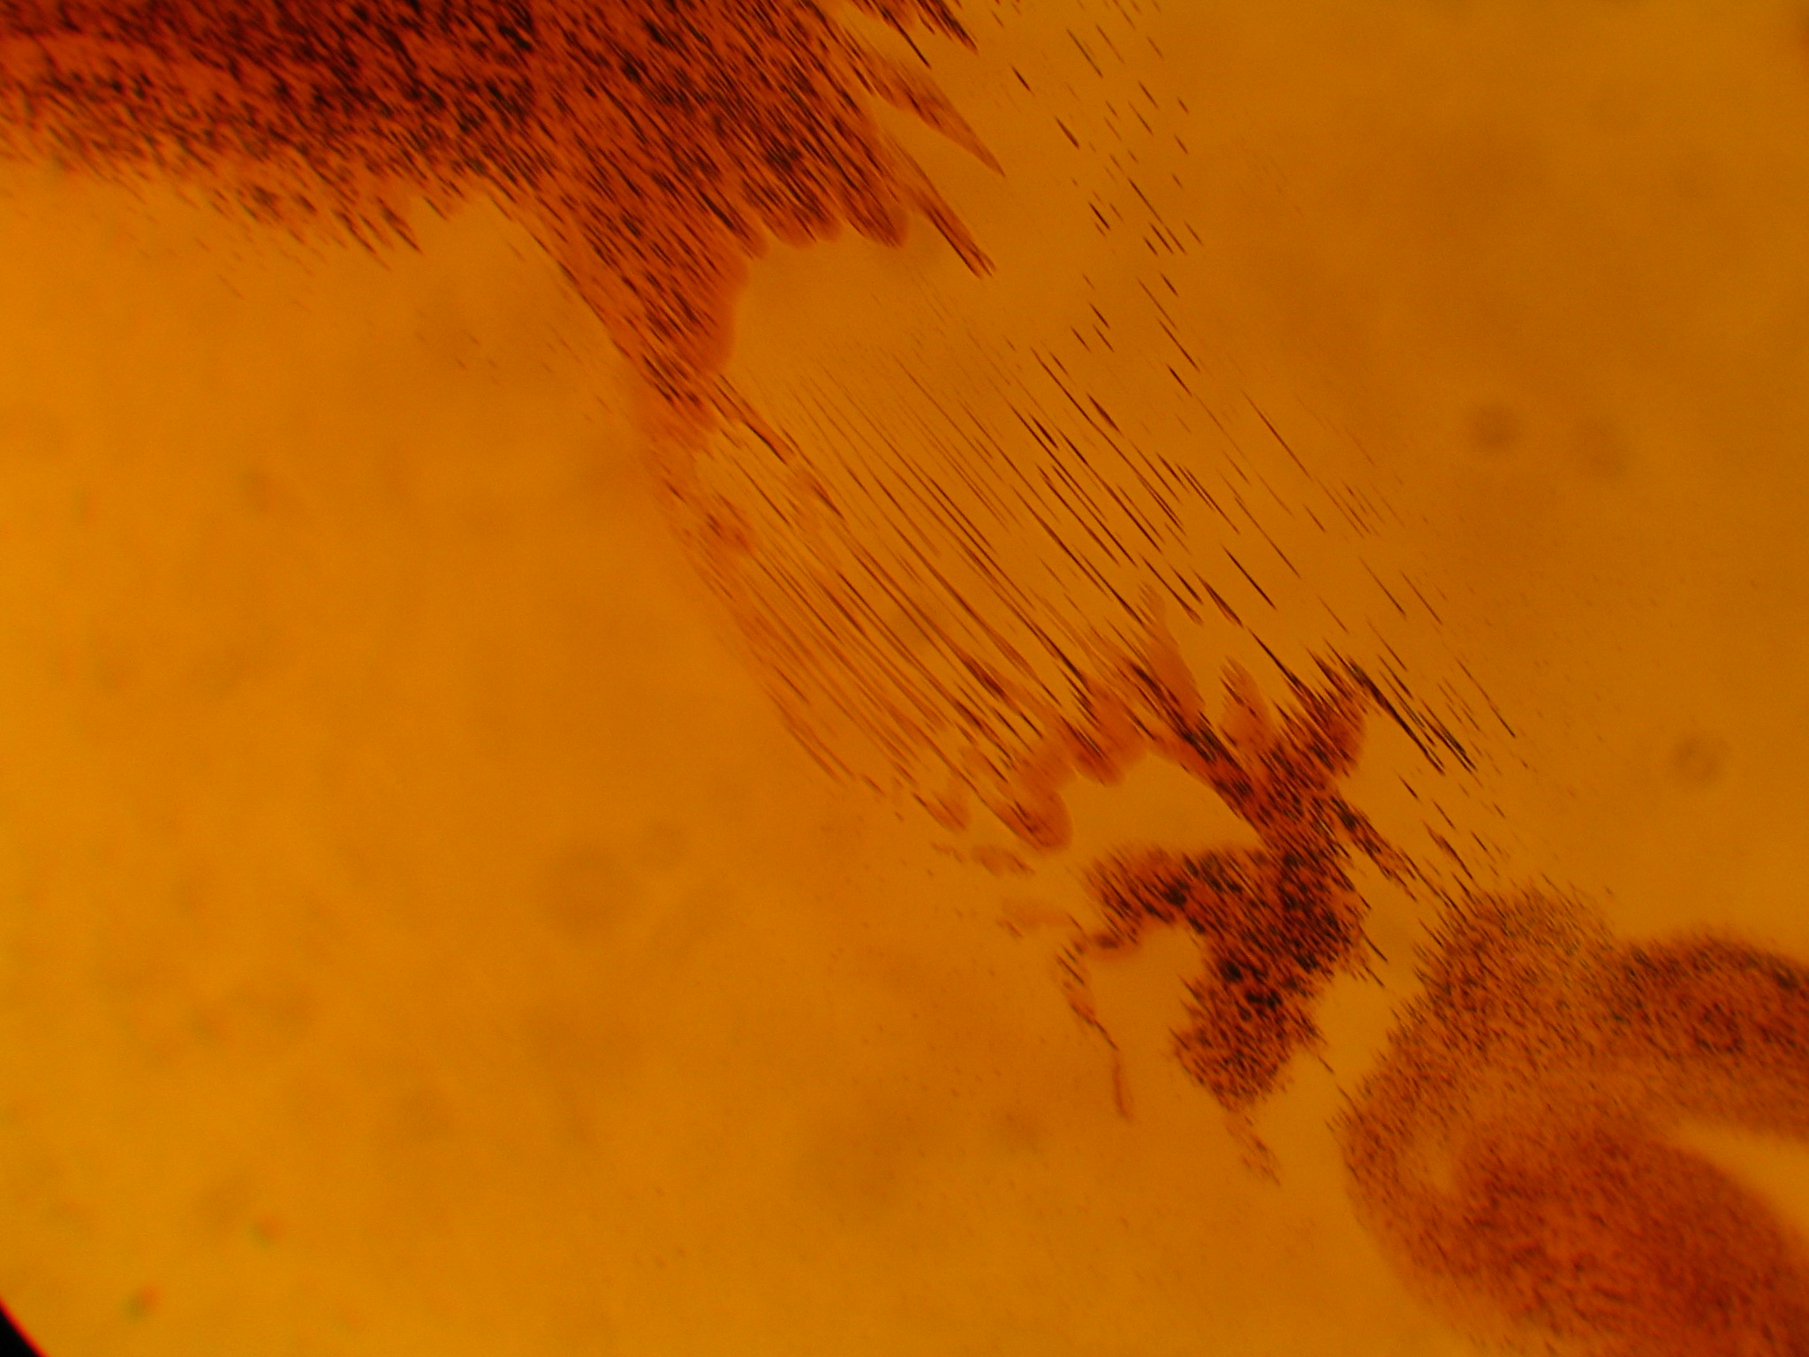
Figure 1 – A microscope slide of 10nm Fe304/Fe203 oil based Ferrofluid

Narrative: I believe that scientific papers need more of a story line in their content. The information density of a standard paper prevents most of humanity from accessing one of mankind's greatest assets. I suggest that the page of text that is written when a paper is published in the mainstream media; be included in the initial paper. For these reasons I'm including a narrative in my paper.
Our story begins with Figure #1, a smear of oil based ferrofluid on a microscope slide. There is a small chip of a permanent magnet on the slide that is not shown, but you can see some dark streaks and structure within the drops of oil.

Those dark streaks are nanoparticles of iron oxides. Specifically magnetite and hematite wrapped with electrostatic neutral surfactant to overcome attractive van der Waals and magnetic forces.

A company called Ferrotec makes this EFH1 ferrofluid and they says it typically contains by volume 5% magnetic solid, 10% surfactant and 85% carrier. One thing that I have found out by trial and error is that the magnetite slowly degrades into hematite. The exact Fe304/Fe203 ratio is not known but my best results has come from using the older ferrofluid in the 2008 year range.

Clearly, one can not see nanoparticles using a optical microscope so why can we see ordered structures in Figure #1? That my friends, is what they call the rest of the story.

"When an external magnetic field is applied to a magnetic fluid film, the particles agglomerate due to the attraction among particles, and magnetic clusters are formed. These magnetic clusters form rich structural patterns. ... With the ordered structures in the magnetic fluid film under external magnetic fields, the refractive index varies periodically over the film." - S. Y. Yang 2005

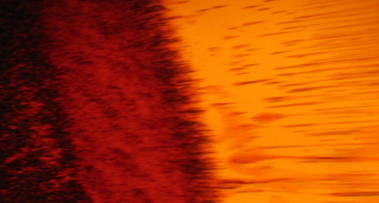
Figure 2 – A 300x microscope picture of moving magnetic agglomerate clusters

What happens is that the surfactant can only keep the nanoparticles apart in weaker magnetic fields. Once you exceed the abilities of the surfactant, the nanoparticles start clumping together and given enough time, they self assemble into micrometer long helical rods.
For many years I have looked at this precipitate and did not realized it's importance. The rods form within the liquid and if given enough time the rods stick to the glass windows. Often, I would disassemble the cells and would have to make a effort with acetone solvent to remove the precipitate.

I did not disregard the precipitate because it was a mystery; but I disregarded it because it was exactly not a mystery. You apply a magnetic field, of course some of the magnetite might come out of solution and stick to the glass. I started this work in 2007 and in 2015 I finally figured out my error when a meta-materials paper was published.

"For a nonmagnetic material, magnetic resonances can be created by resonating loops of displacement current. This can be achieved in closely packed subwavelength metallic nanoparticles. The boundary conditions at the surfaces of the nanoparticle dictate that the direction of the electric field should always be normal to the surface of the particle. Therefore, in circularly arranged nanoparticles, at each boundary the electric field rotates slightly, leading to a full circulation of the light's electric field at a resonance. ... Because the metal doesn’t touch the electrons can only oscillate within individual particles and can’t move from one nanoparticle to its neighbor. This is known as a displacement current. It’s like doing the wave in a stadium; no one fan is moving from their seat, but the wave moves around in a circle." - Nader Engheta - 2015

In Figure #2 I am showing the micrometer long helical rods precipitating out of a light oil and traveling to a permanent magnet chip. Notice how well ordered the self assembled magnetic agglomerate clusters are aligning themselves.

Once I had read Dr. Engheta's paper everything started making sense. I had assumed a precipitate of nanoparticles would have the same physical properties as the bulk material. Not once did I imagine that a agglomerate of nanoparticles could have physical properties that is different than the bulk material nor a solution of nanoparticles.

To be fair, Dr. Engheta works with metal nanoparticles and I work with magnetic metal-oxide nanoparticles but I believe his displacement current idea is correct. If we treat each nanoparticle as an isolated group of electrons and then an agglomerate of nanoparticles is treated as many groups of isolated groups of electrons, which are electromagnetically coupled each together; then my ferrofluid cells are showing optical resonances which corresponds to the magnetic agglomerate clusters resonating.

Another name for electrostatic neutral surfactant would be an insulating surfactant which means each nanoparticle has a small amount of capacitance. Referring to Figure #3, each ferrofluid particle has a magnetic moment which we could call inductance, and magnetite is known to have magnetoresistance. I have a background in electronics and can easily believe that each magnetic metal-oxide nanoparticle can be modeled as a RLC oscillator, and when you couple them together in an agglomerate, it is a large system of coupled oscillators. No wonder that I have photographs of optical resonances.
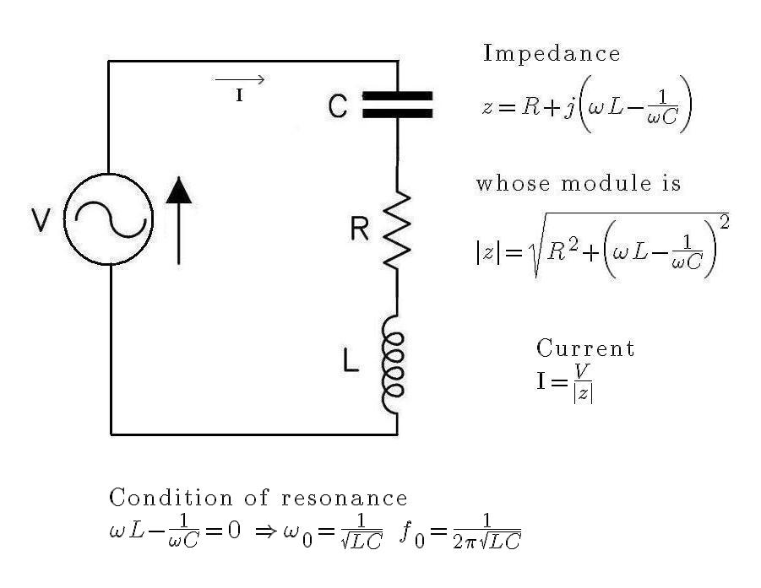
Figure 3 – Each metal-oxide nanoparticle can be modeled as a RLC oscillator

I claim that in Figure #1 and Figure #2 that we are looking at electromagnetic oscillators which are coupled to both electric and magnetic fields of their environment. Later in the document I will be flooding the ferrofluid cells with photons and measuring the back scatter at a 45 degree angle of incidence.

My point being that not only do we have a system of oscillators but we have a large amount of incoming high frequency energy in the form of photons that drives the system.

One problem is how are these micrometer sized structures oscillating at optical frequencies? One would not expect the large agglomerate clusters to have this ability. I believe the answer is that you have to remember that there's a large number of individual nanoparticles that are still in the solution.

I can imagine a system where the agglomerate clusters are oscillating at a lower primary frequency in the terahertz range, and the single nanoparticles in the solution are oscillating at a higher harmonic optical frequency.

In electronics we have the Skin Effect where the high frequencies travel on outside surface of copper wires. How do you define the surface of the agglomerate clusters? Do you include the ferrimagnetic nanoparticles that are magnetically bound, but are not physically touching it? What is the high frequency permeability of ferrimagnetic nanoparticles in general? Do the opposing magnetic moments produce a fractional Mu?
Clearly, I have more questions than answers but no one can be an expert at everything.

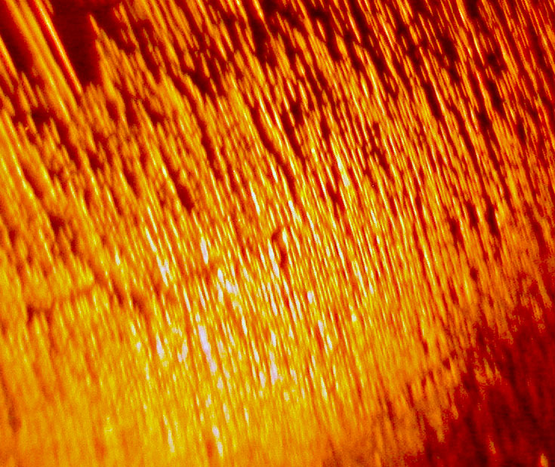
Figure 4 – A 100x microscope picture of millimeter sized agglomerate rods.

In Figure #4 we see in over 15 minutes that the magnetic agglomerate clusters have formed a network of millimeter sized rods aligned along the magnetic field lines. This leads to another question, is Figure #4 a picture of a metasurface?

In 2005, Dr. S. Y. Yang called his magnetic agglomerate clusters a photonic crystal with the ordered structures, that produces a refractive index that varies periodically over the film. In 2015, this sounds like the definition of metasurface. Just think, if Figure #4 shows helical rods of photonic crystal, that sounds useful for self assembled optics.

"Ordinary mirrors reflect light over a broad range of frequencies, but a new mirror design can reflect a single frequency while allowing all others through. This “metamirror,” an array of subwavelength pieces of shaped metal embedded in a transparent medium, can also be made to reflect light in a chosen direction or focus it like a curved mirror. The shape of the inclusion affects the phase of the scattered microwave light the timing of its wave crests in relation to the incoming light—and the net effect of the right combination of shapes is to reinforce one specific direction for the scattered waves. The team’s metasurface design includes a variety of inclusion shapes, placed in a two-dimensional geometric pattern. The inclusions all respond to the same frequency, allowing other frequencies to pass through unaffected. Using computer simulations, the researchers showed that they could design an array that completely reflected an incoming light wave at any angle they wished." V. S. Asadchy 2015
My understanding of a metamirror is that it uses oscillating dipoles to scatter photons. Later in this document I have page after page of magnetic dipoles that are scattering photons. The inventor of the Ferrofluid cell, Timm Vanderelli has been selling cells since 2004. As a physics undergrad I needed a senior final project and bought a cell. I think my words at the time about explaining how the cells work was,

"How hard could it be?"
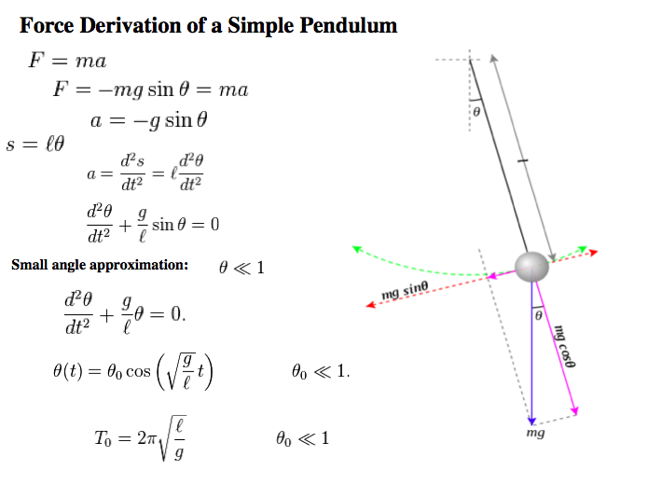
Figure 5 – The frequency of harmonic oscillator is a function of the potential.

The last point of this section I wanted to address is the ferrofluid cells tend to show potential energy contours of the applied filed. In Figure #6 there is a small permanent magnet behind one of the ferrofluid cells with its perimeter leds turned on. The image itself is made of many ellipses of photon scatter but our minds tend to average out the ellipses into a system of concentric circles. Not surprisingly the potential energy of a magnetic pole is a system of concentric circles.

This is not an accident, I can show that if you average out the scatter lines in the ferrofluid cell photographs, it reduces to a potential energy plot of the applied field.

Which brings up the question, how does the ferrofluid cell show the potential energy levels of the applied field?

Unlike conventional magnetic fluid deformable mirror technology, the ferrofluid cells are sealed and there is no free surface other than the surfaces of the window and the mirror.
Instead I think the answer comes from first principles. We need to switch models from a RLC tank to a true harmonic oscillator. The simple pendulum seen in Figure #5 will do.
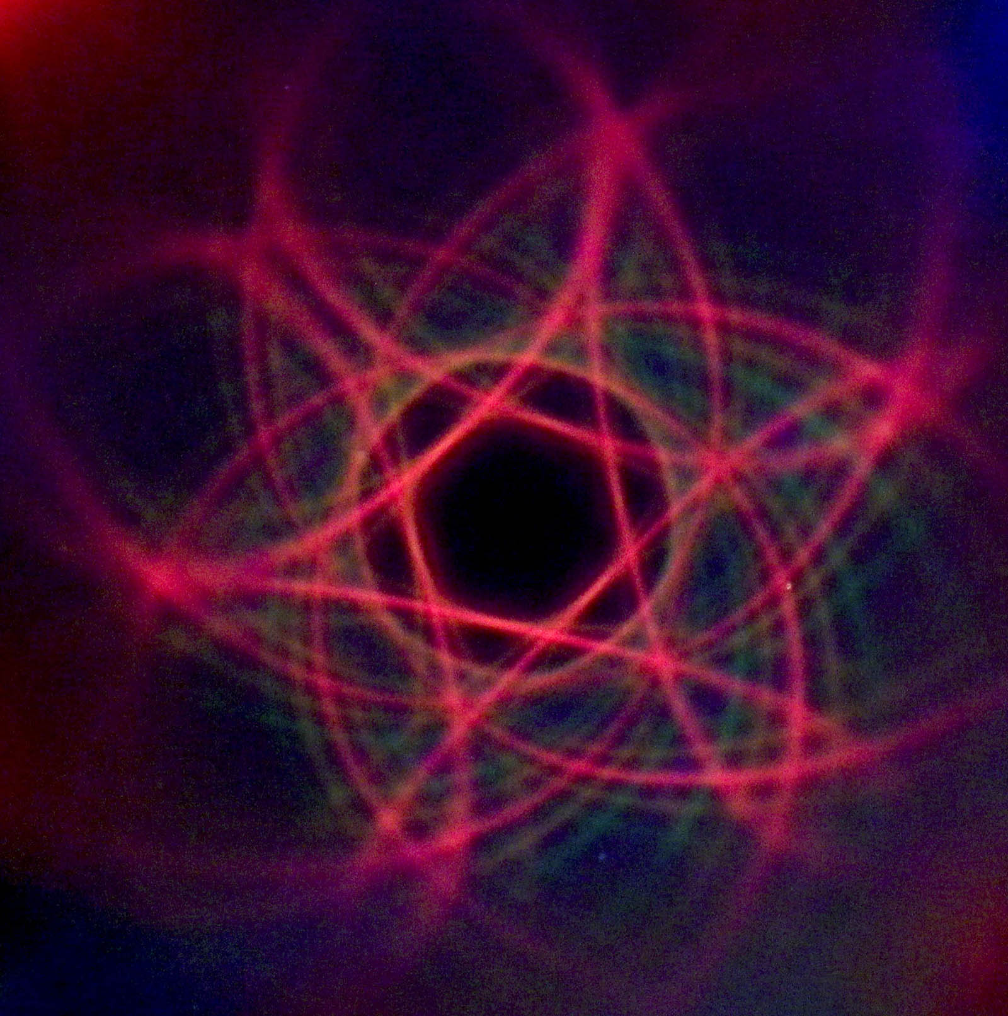
Figure 6 – A single permanent magnet pole applied behind a ferrofluid cell.

Clearly, the light only scatters back to the camera in Figure #6 when the local electric or magnetic dipole resonance within the cell matches the polarization and poynting vector of the incoming light. Since the same photons are driving the resonance within the cell, it is not surprising that the resonances can propagate within the cell as a chain reaction.

But why do the lines of resonance follow the potential energy contours of the applied field? In Figure #5, we see the period of pendulum is a function of the potential 'g'. 'g' is the attraction between the pendulum and the earth. Anyone who has taken Quantum Mechanics knows that frequency of a harmonic oscillator is a function of its potential.

The ferrofluid cells are a driven system with a large applied magnetic field, first the incoming photons cause the system to oscillate and then the oscillations cause the system to scatter the same photons that caused it to oscillate.

This wave of resonance is free to propagate to other oscillators of the same frequency. But where in the ferrofluid cell do you find other oscillators of the same frequency?

From the RLC model, remember the ferrimagnetic nanoparticles have magnetoresistance. The oscillation frequency will a function of the magnetoresistance and magnetoresistance is a function of the applied field. Or on the other hand, you can just say that the harmonic oscillator frequencies is a direct function of potential of the applied magnetic field.

Either way, we can now imagine a system of concentric circles of harmonic oscillators with slightly different oscillator frequencies per circle. The driven resonance wave coming from the light source can only effectively propagate to the other resonators like itself, which happens to be along the potential energy contours.

I believe that the reason that the potential energy contours show up in the ferrofluid cell photographs is because that is the path of maximum resonant energy transfer from oscillator to oscillator within the cell. It is the same reason that humans walk along ridge lines instead of rolling hills, it is much more energy efficient to propagate at the same potential.

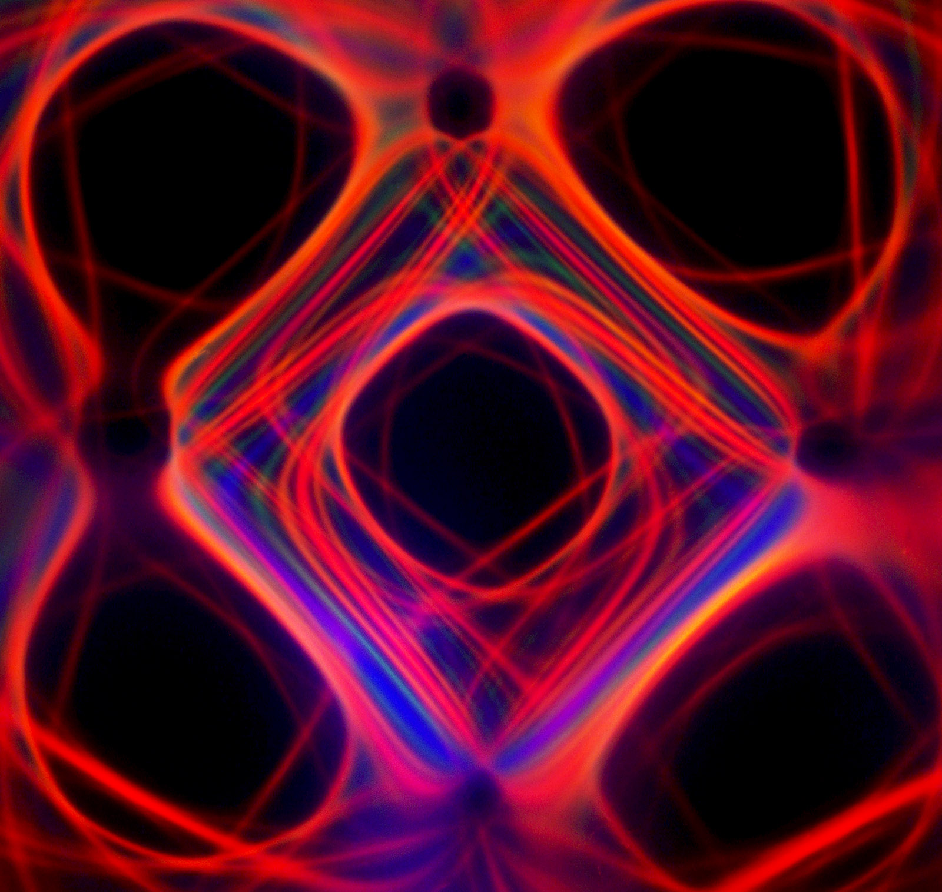
Figure 7 – Five permanent magnet poles applied behind a ferrofluid cell.

Hopefully the reader will a agree that no matter what we call the ferrofluid cell seen in Figure #7, be it a Kerr photonic crystal or a metamirror or the forerunner of a self assembled optical computer with dynamic circuits along magnetic field lines; that the image will stay the same.

Main Body: I have been asked to apply some math to the ferrofluid cells that I study. For example, people wish to know the thickness of the ferrofluid layer in the cell. For some reason saying three to five drops of ferrofluid is not a satisfactory answer.

The ferrofluid cell seen in Figure #8 that I am going to model is made up of BK7 glass window that is 100mm in diameter and 6mm in thickness. Then there is a layer of a mixture of Fe3O4 and Fe2O3 ferrofluid particles of an average 10nm size suspended in light oil. Below the ferrofluid layer is an aluminum surface mirror that 100mm in diameter and 3mm in thickness. The top window is rated at ¼ wave flatness at 650nm.

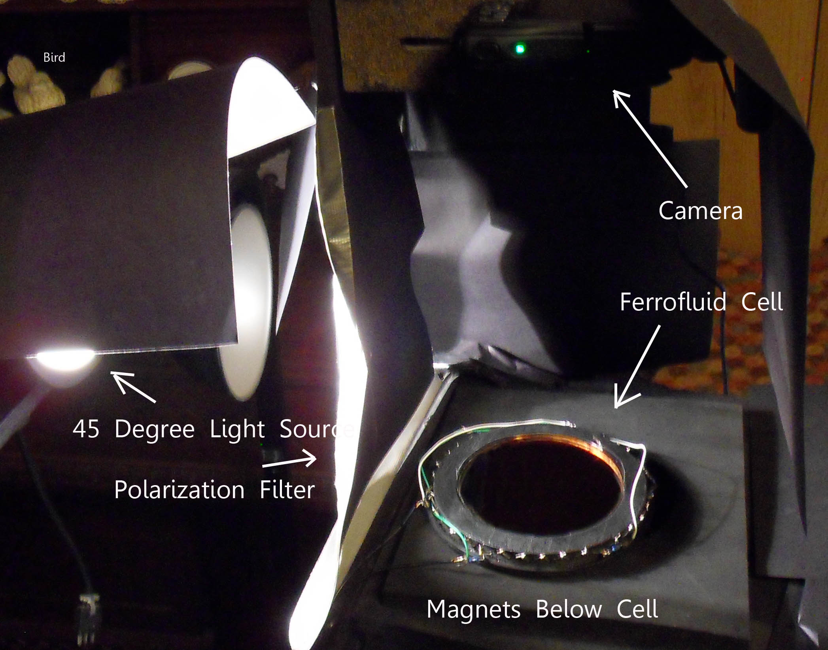
Figure 8 – Layout of ferrofluid cell experiment.

In my experiments white light is projected onto the ferrofluid cell with 45 degree incident angle and a magnetic pole of a permanent magnet is placed under the mirror. The field of a permanent magnet produces hysteresis shaped patterns when viewed from directly above the ferrofluid cell.

Surely the 45 degree incident angle between the light source and camera is a strong argument to characterize the ferrofluid cells as a metamirror. A argument for displacement current is that ferrofluid cells are made up of glass, oil, and rust. There are not many conduction band electrons in the system YET we know from first principals that it takes electrons to scatter photons. How does this device scatter light without conduction band electrons? Of course the aluminum surface mirror scatters light at 90 degrees but I'm referring to the non-90 degree scatter. One can build a ferrofluid cell with two glass windows and obtain very similar results to the data in this document.

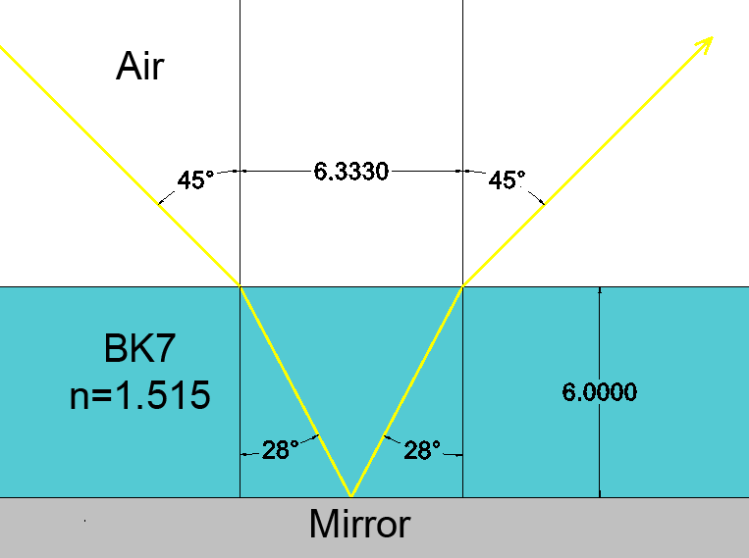
Figure 9 – Applying classical optics to the ferrofluid cell.

Starting with Figure #9, a light ray from the left hand side approaches the center of the ferrofluid cell at 45 degrees. Of course other light rays from the same source with be a bit less than 45 degrees on the left hand side of the cell and a bit more than 45 degrees on the right hand side of the cell. The average index of refraction of BK7 is around 1.515 .

I did some checking and light machine oil which seems to have similar viscosity as the ferrofluid medium and can be measured at 15 drops per cubic centimeter. Doing the math, it works out to 8.4 micrometers per drop of height for the 100mm diameter ferrofluid layer. Assuming I used 5 drops of ferrofluid, that gives 42 microns of thickness for the layer.

The average index for refection for light machine oil is around 1.45 which is pretty close to the index of refraction of the BK7 glass. The light ray comes in at 45 degrees and hits the first glass interface which changes it to 27.82 degrees and it travels thru the 6mm thick BK7 glass. Then the light ray hits the second glass interface and changes the incident angle to 29.23 degrees.

After it travels through the 42 micron thick ferrofluid layer then the light ray hits the aluminum surface and using the law of reflection, the incident angle becomes -29.23 degrees. I ran the numbers, but course the system is symmetric and light ray follows the same angles that brought it into the system and exits the top glass interface 6.33mm downstream at -45 degrees.

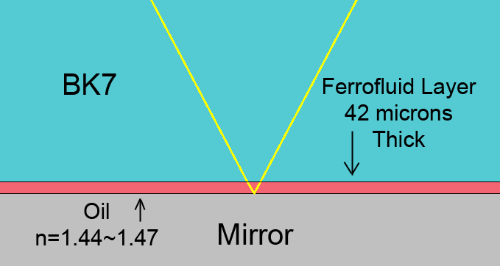
Figure 10 – Zoomed in on the ferrofluid layer.

The Brewster's angle of Bk7 glass 56.56 degrees which leads to an interesting observation. Notice that in the experiment the incident angle inside the glass was 27.82 degrees. If you run the numbers, you will find that it is impossible to trap light inside the cell using the Brewster’s angle for either the BK7 glass layer and/or the ferrofluid layer.

If you inject light from the top the cell; you can not trap it inside the cell!

Another observation is that the ferrofluid layer is over 140 times thinner than the glass window about it. This means that the light is spending 140 times more time in the glass layer, versus the time that it spends in the ferrofluid. The maximum path length of the light passing though ferrofluid is less than 120 microns.

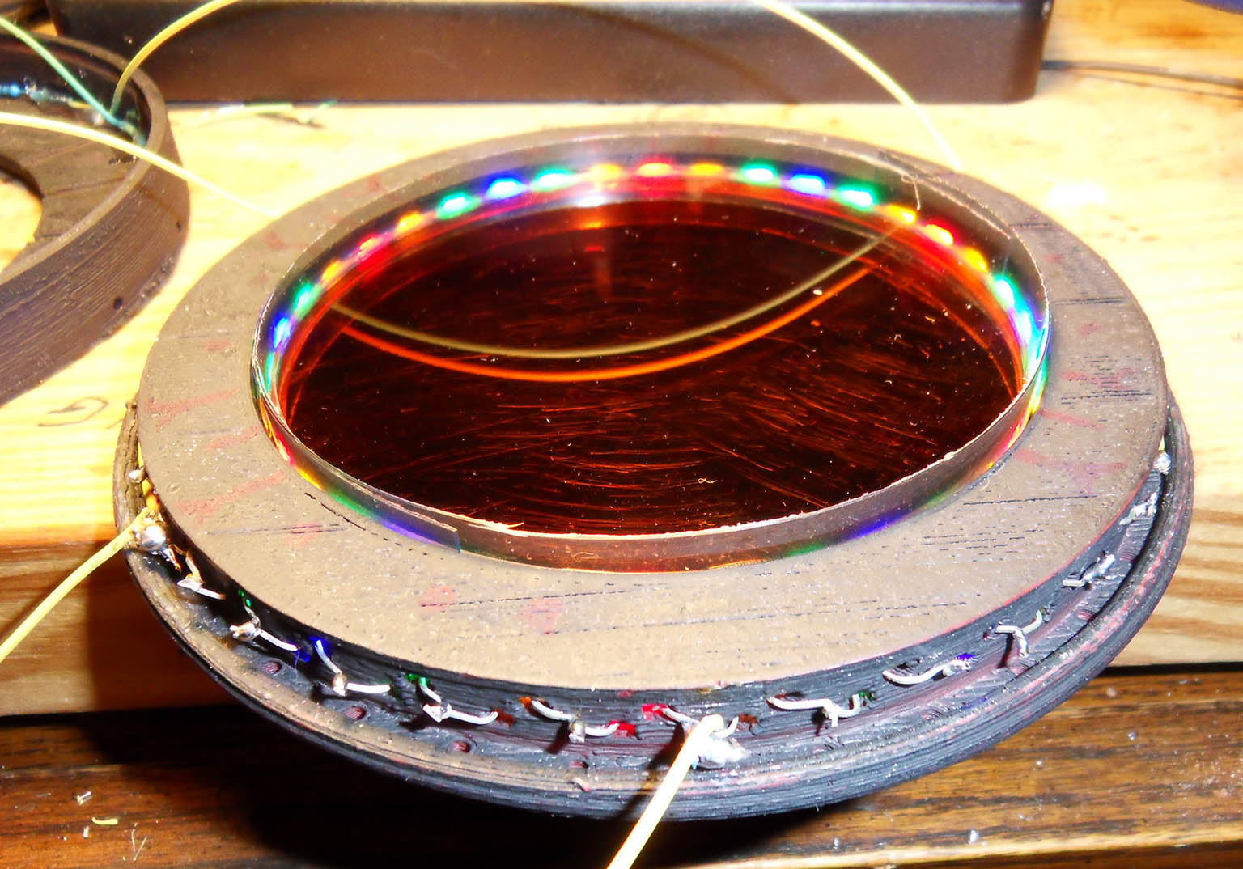
Figure 11 – Testing a new ferrofluid cell, note the color change of the wire.
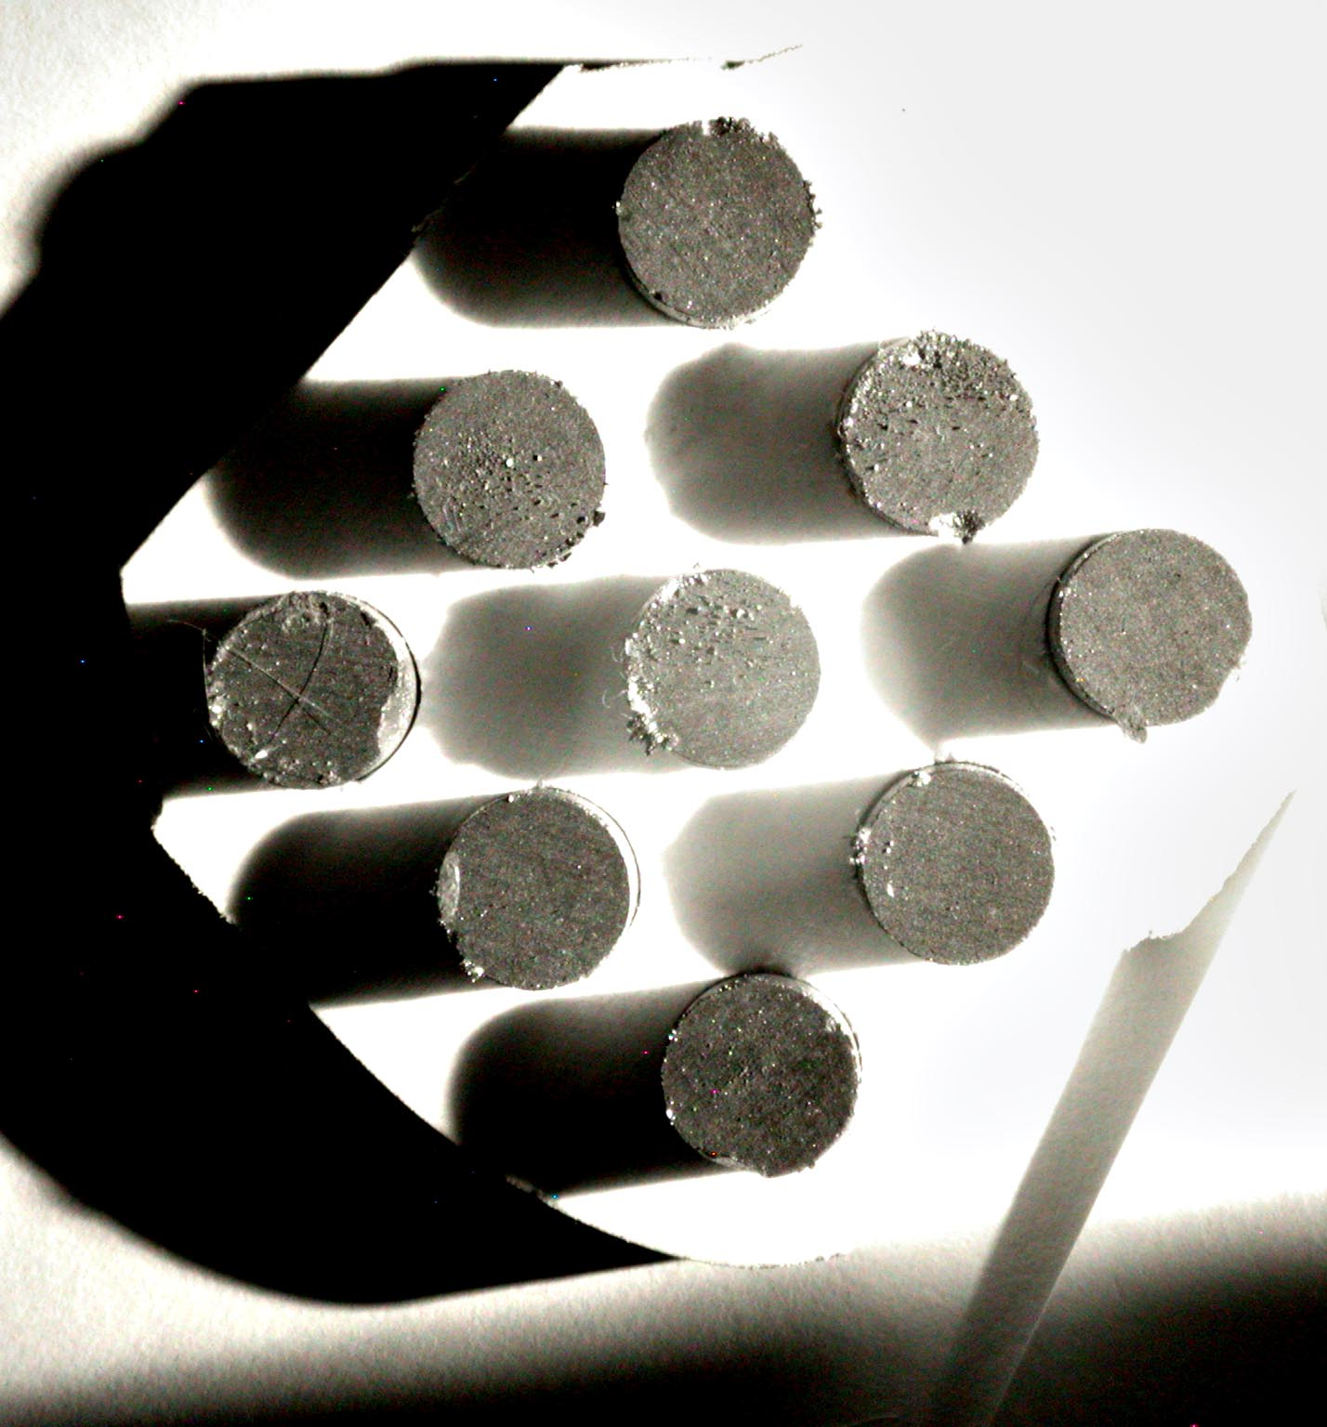
Figure 12 – Picture of nine shiny magnets using a polarized filter.

In Figure #11 I am showing a new ferrofluid cell with it's perimeter leds being tested. Note the color change of the yellow wire in the double reflection. The first reflected image is from the top surface of the glass and the second reflection is from light that has traveled through the ferrofluid layer. Obviously, the cell does not reflect blue light well.

Figure #12 is a picture of nine shiny Samarium–cobalt magnets in a plastic jig and I am testing a polarized filter on the camera. Not shown but when I rotated the polarized filter the shadows of the magnets stayed at the same intensity but magnets became shiny. Each magnet is 12mm in diameter and 25mm tall. I will use the array of magnets (N,S,N;S,N,S;N,S,N) as the standard applied field in the rest of the document.

Some final observations of Figures #9 and #10 is that because we know light is at 29.23 degrees while in the ferrofluid layer and that the camera takes pictures from above the ferrofluid cell; there are two ways for a light ray to get the camera; one is for the light ray to bend upward -29.23 degrees BEFORE it gets to the ferrofluid/glass interface or to bend downward an additional 15.76 degrees in order to strike the mirror surface and then travel straight up to the camera.

In both these scenarios you would need over 15 degrees divergence of the light ray within a path length of less than 120 microns. I feel confident in saying that classical refraction optics CAN NOT fulfill these requirements!

Birefringence and Faraday rotation do not bend light quickly; light propagates at one foot per nanosecond and thus the light is only spending only a few picoseconds inside the ferrofluid. I ran some numbers and just using classical optics, I would need a local index of refraction of over 4, (n>4), or a local index of refection less than 1.

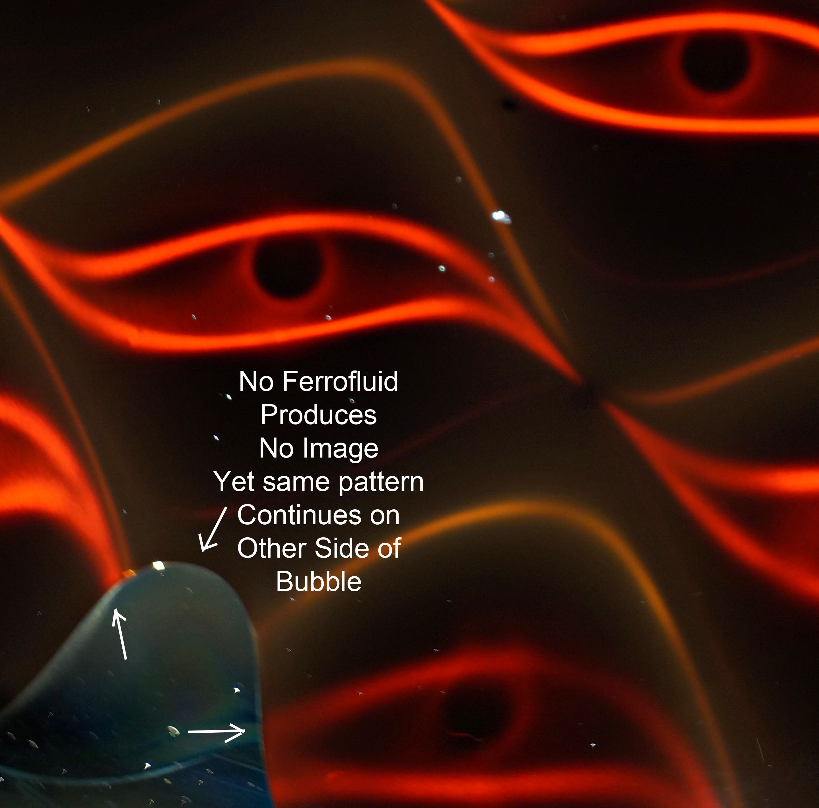
Figure 13 – Notice that the pattern seen in the ferrofluid continues across bubble.

Changing gears to Figure #13, there are two things to notice. First notice that the hysteresis shaped pattern(s) continue even thought that the there is a bubble of air inside the ferrofluid cell. Clearly the image is truncated at the ferrofluid/air interface with little edge distortion yet the image reappears on the other side of bubble. Notice at this camera angle, the mirror does not show an reflection.

Another observation is that there’s a flaw on the glass surface around 1’oclock that is casting a shadow seen at the top right center of the cell. There is no sign of light from other parts of the cell bleeding into the shadow area. I claim that the border of the shadow is well defined, and this argues against Diffraction being the primary cause of the hysteresis shape.
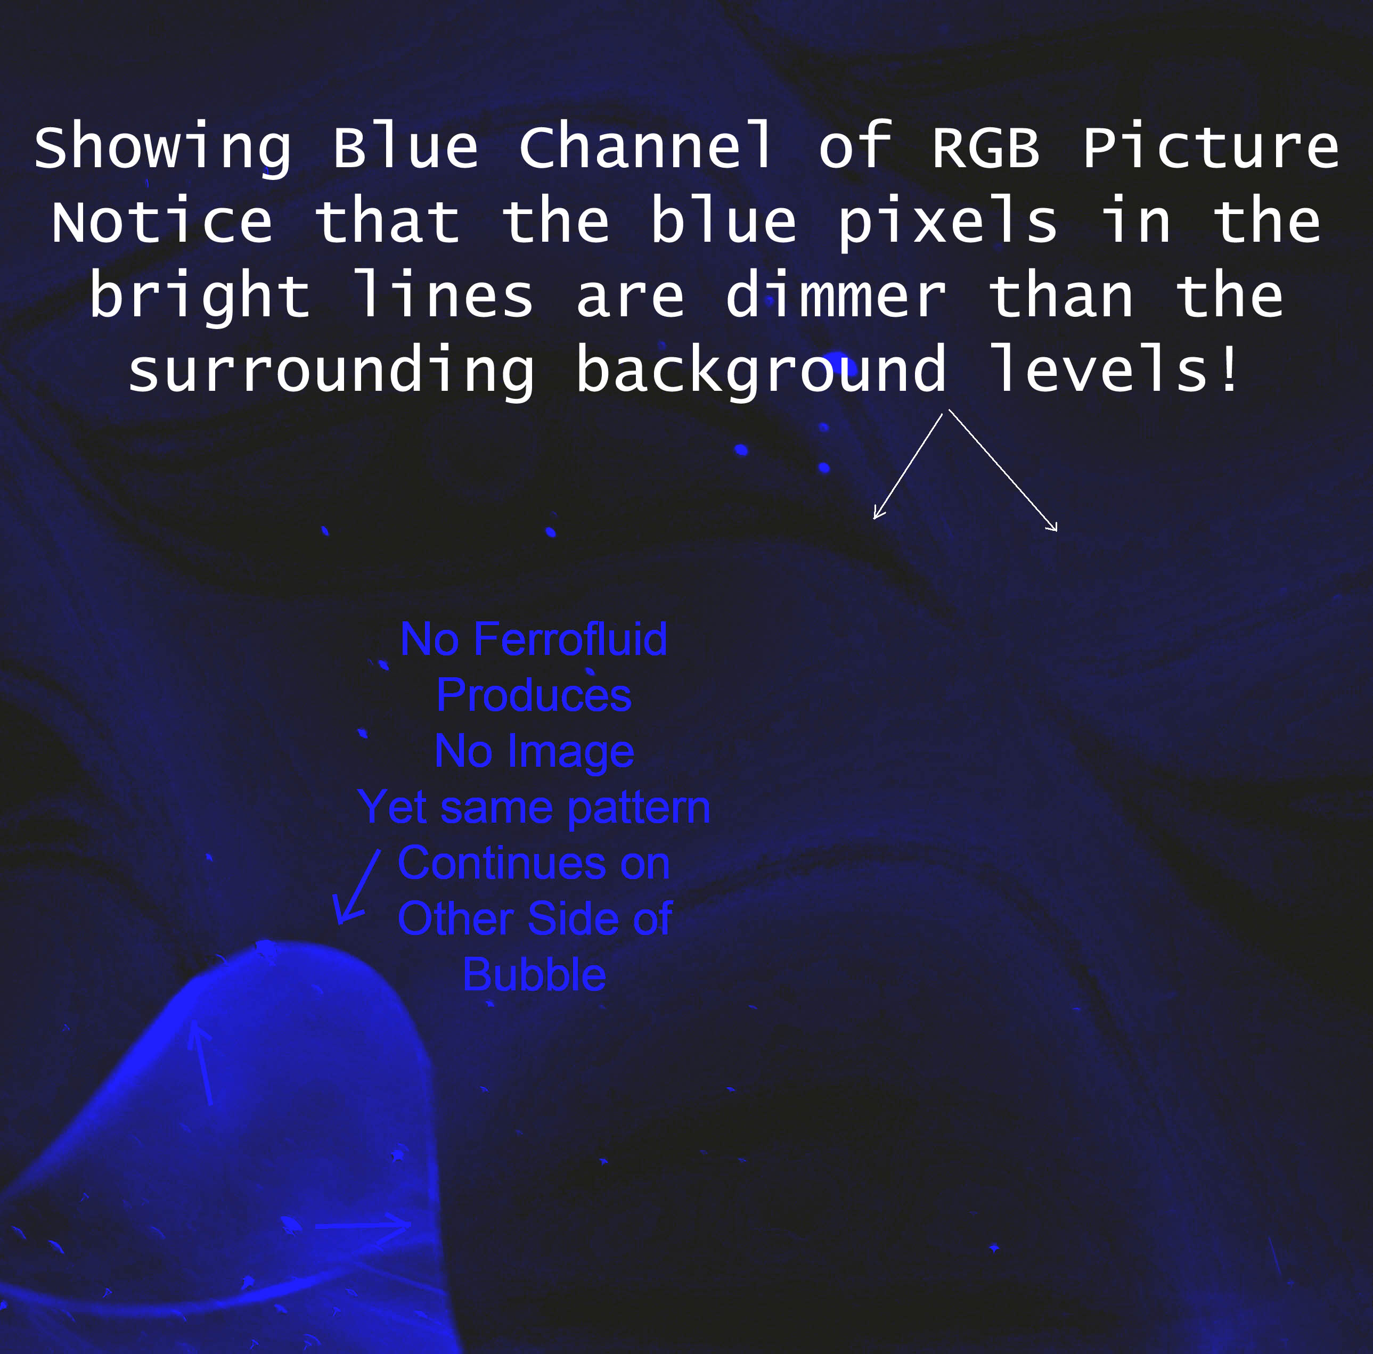
Figure 14 – Showing magnetically controlled absorption of blue light.

Note that the lack of scatter signal from a shaded area of the cell does prove a lack of resonance at that location, because without incoming photons how can you have scatter?

Figure #14 is just the blue channel of the RGB photograph of Figure #13. Cameras detect photons on three different color channels and we can turn off the red and green and just look at the blue. Clearly we can see that where the red lines show up in Figure #13 that a ‘lack’ of lines show up in Figure #14.

If you compare the red channel and the blue channel, you would find that they are inverted images of each other in regards to the hysteresis shaped patterns. We can say this is blue light extinction or absorption or non-reflection but clearly the photograph is missing some blue photons. Note the white dust on the ferrofluid cell in the black areas of Figure #14, this shows that the camera is working correctly, and that the blue light levels of hysteresis shaped patterns are below the baseline blue light levels!

I was able to get my Ocean Optics PC1000 spectrometer working and was able to get some readings. My incandescent light source is a 1000 watt bulb salvaged from surplus equipment. I also used a green laser pointer to verify my calibration.

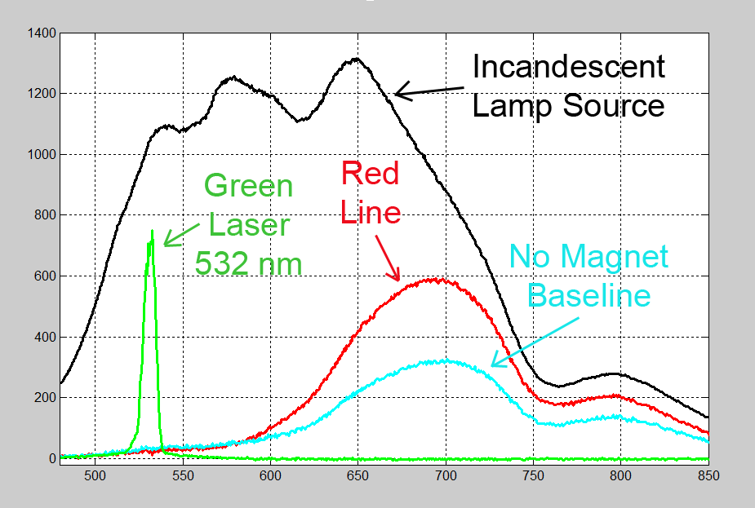
Figure 15 - Spectrum readings from a Ocean Optics PC1000 spectrometer.

The black line of the Figure #15, is the spectrum of the incandescent lamp and the green line is the spectrum of a green laser pointer. These are scaled to fit onto the graph.

The teal line are the readings with the lamp turned on and the probe resting on top of the cell which is 6mm over the ferrofluid layer. Surprisingly the ferrofluid layer is always scattering light around the 700nm range. Not surprising is that much more red light is being scattered than blue light. Comparing light in to light out; there are very few blue photons being scattered to the camera and/or the spectrograph probe.

When we apply a magnetic field and align the red lines that show up in the images under the spectrograph probe, the result is the red line of Figure #13. Notice around 550nm the red line dips below the teal line. This is consistent with Figure #14 and the depletion of the blue photons.

The red line and teal lines have the same scales. If we look at 600nm, we can see there is a lot of red photons coming from the source that are not getting scattered to the camera but at 800nm which has lower intensity levels from the source, the ferrofluid cell scatters many more of the supplied infrared photons.

Just going by the graph, I can tell that the ferrofluid cells are more efficient at scattering near-optical infrared frequencies than they are at optical frequencies. It's like looking at an iceberg and realizing that the iceberg is larger below the water line. In other words, after seven years am just starting to realize what a ferrofluid cell can do.
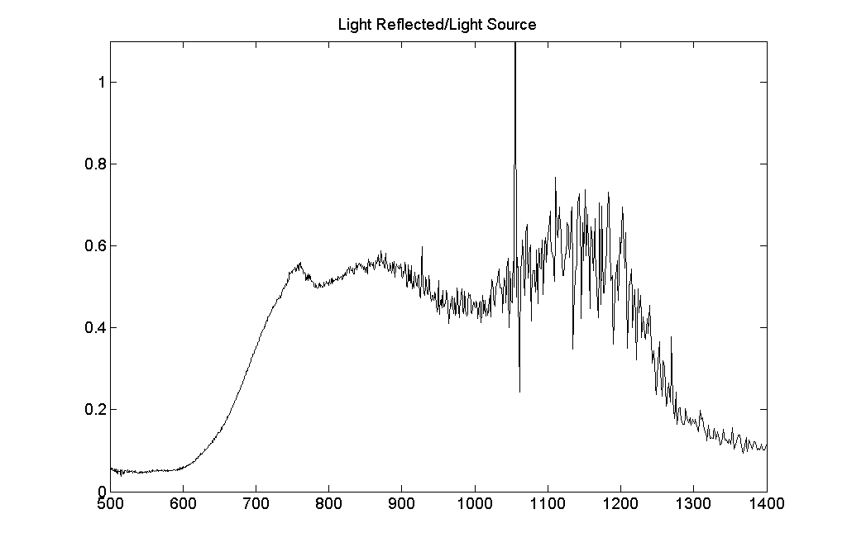
Figure 16 - Baseline NIR reading at 45 degrees incidence divided by source spectrum.

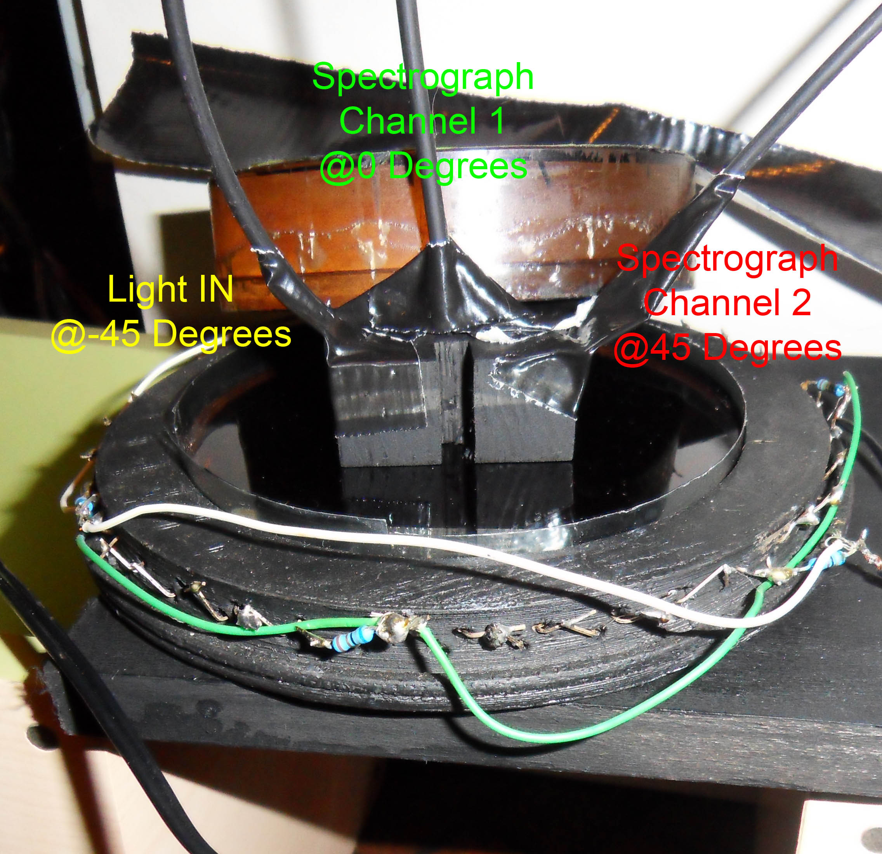
Figure 17 – Layout of second experiment with two spectrograph channels.
Second Experiment: After I had the Ocean Optics PC1000 NIR spectrometer working, I obtained two PC2000 spectrometers that can read from 300nm to 1000nm. In the previous section I was using one PC1000 with an integration time of two seconds. In this section I am using the two PC2000 spectrometers with the integration time set to 250ms. Quite a bit of improvement compared to the first generation of pc spectrographs.

In Figure #17, the light is being injected via a fiber optic cable at -45 degrees and then I have two fiber optic probes taking readings at 0 and 45 degrees normal to the cell. The light entrance and exit orifices, of a piece of wood are spaced apart 6.33mm per the earlier calculations in Figure #9. The piece of wood is holding the fiber optic probes which is above ferrofluid cell with a large BK7 window resting on the jig.
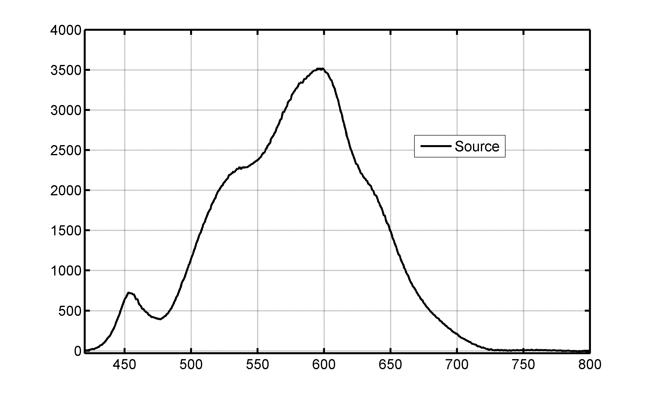
Figure 18 – White LED Light source readings.
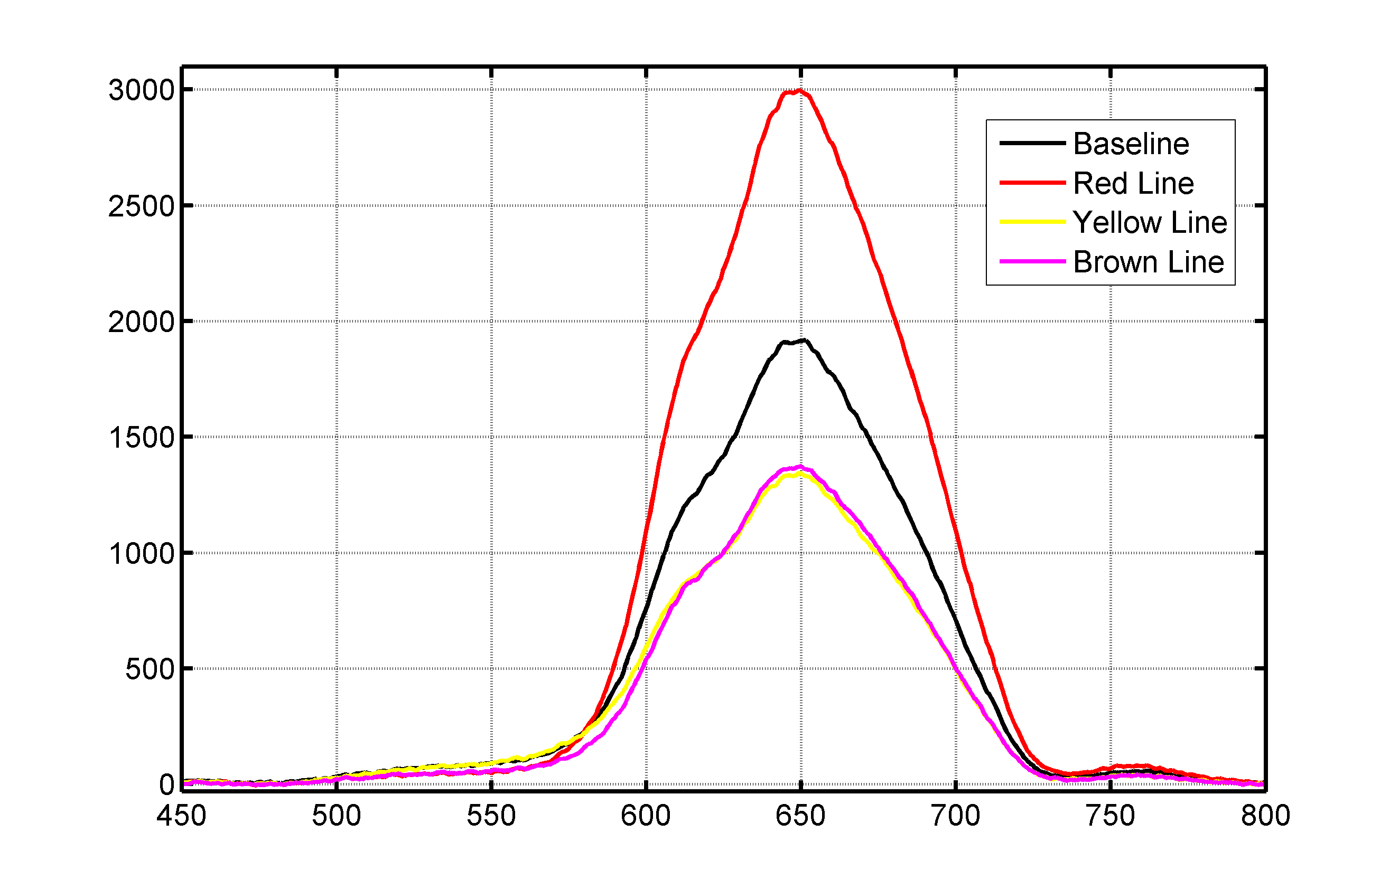
Figure 19 – Ferrofluid cell readings using the 45 degree incidence channel.
In this second experiment my light source is a twenty watt white LED pointed directly into the fiber optic cable and its spectrum readings are seen in Figure #18.

In Figure #19 I am showing the readings from the 45 degree incidence channel. The black line is ferrofluid cell without a applied field. The red line of graph is the ferrofluid cell with a red line of the ferrofluid cell aligned under the fiber optic probe. The yellow and brown line readings from the Ferrofluid cell are labeled and an example of the lines themselves is shown in Figure #20

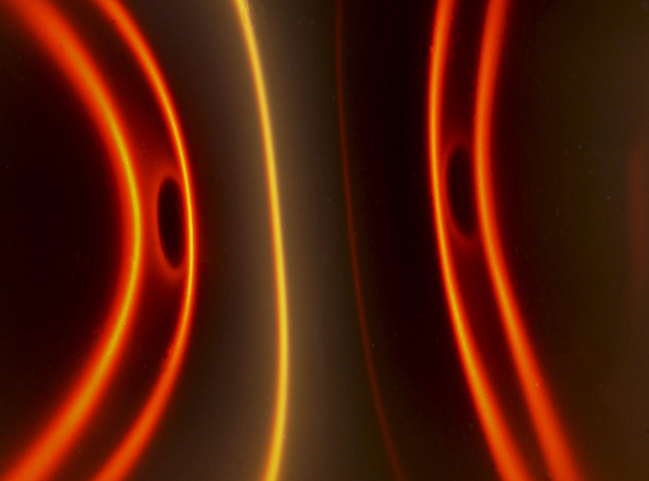
Figure 20 – A bar magnet under the cell, showing red, yellow, and brown lines.
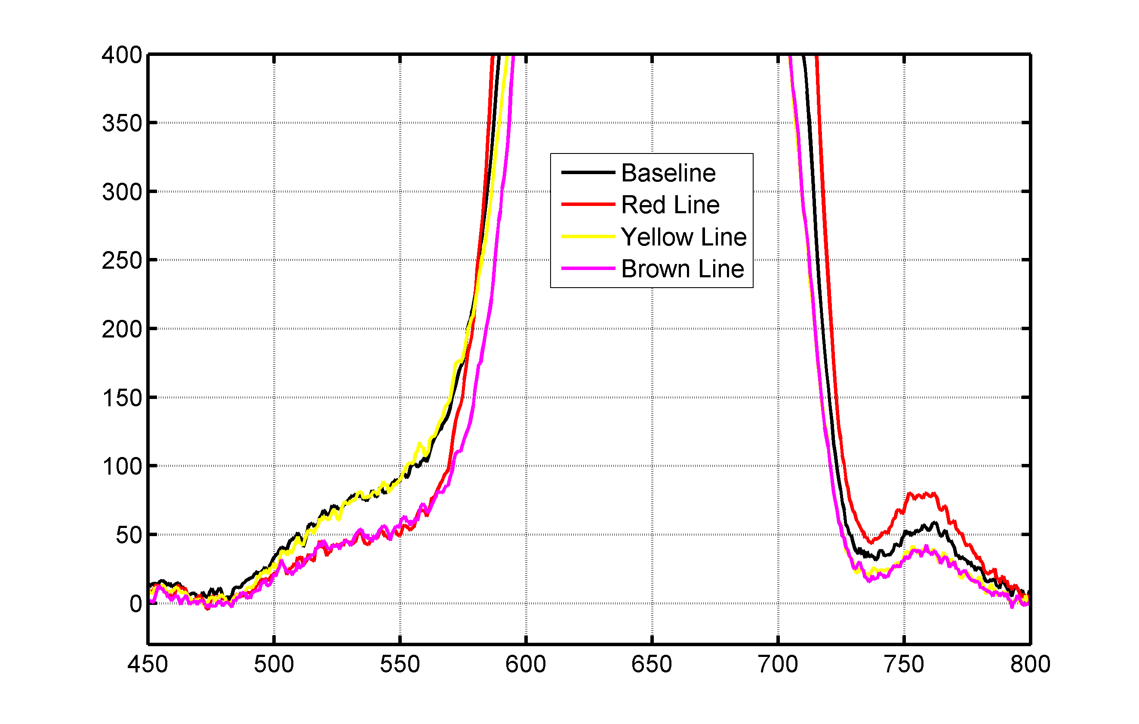
Figure 21 – Ferrofluid cell readings using the 45 degree incidence channel.
Keeping in mind that 45 degree incidence channel showed that the yellow and brown lines have the same peak reading at around 650 nm, lets look at he shoulders of the of yellow and brown lines. Figure #21 is a zoomed in version of Figure #19, notice that yellow line reading has more green wavelengths than the brown line reading at around 550nm.

The yellow line and the baseline share the same spectrum features and the red and brown lines share some features. This will become important at the end of the document. I will show that each yellow line shares the same polarization. We can already see that all the lines share 90 percent of the spectrum readings and the only real difference is small amount of blue and green frequencies.

One interesting thing is that none of these colors are pure colors, the yellow line only appears yellow because of the RGB mixture of many frequencies. This is same trick that our cameras and computer monitors use to represent composite colors

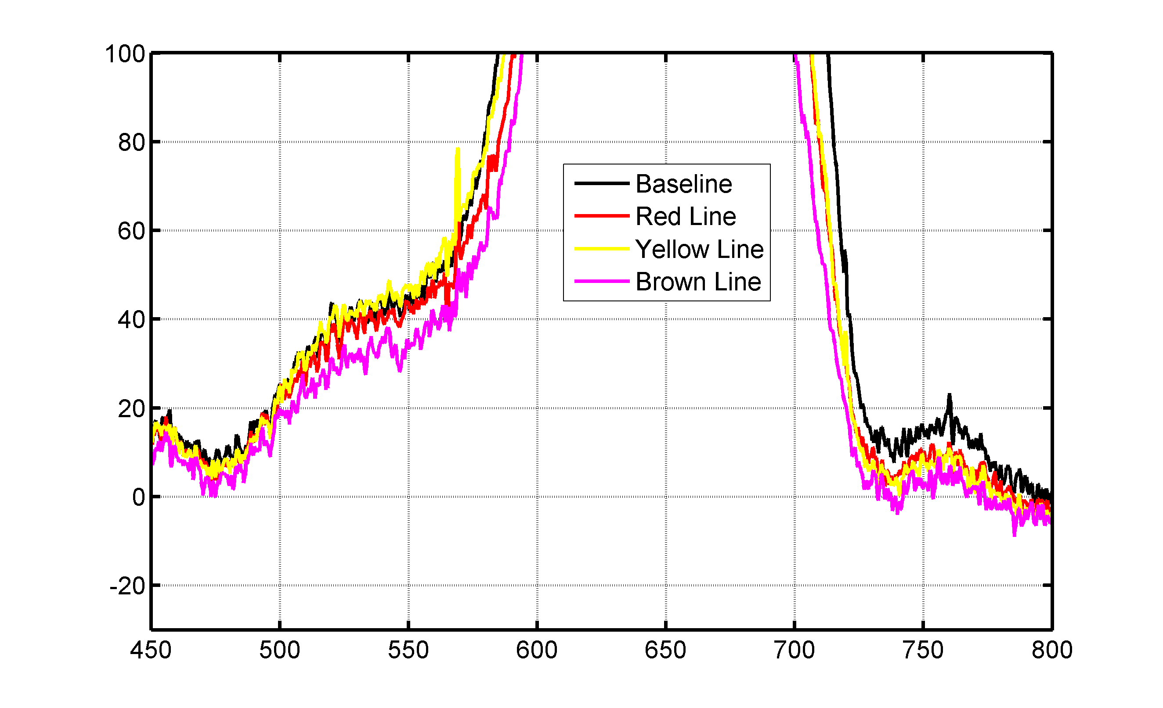
Figure 22 – Ferrofluid cell readings using the 90 degree incidence channel.

In Figure #22 we see the light that made it to the aluminum surface mirror and exited the system at 90 degree incidence. The data shows that yellow lines require less total deflection of the incoming light than the redlines. This makes sense that if the photons are showing up in the 45 degree incidence channel, then it must be missing from the 90 degree channel.

Third Experiment: I went to my local dollar store and obtained some consumer grade dye filters. These filters are normally used for the lighting effects of parties and garage bands. The first thing I did was to take spectrum transmission readings using my incandescent light source, show in Figure #23.

The names I used for the filters is based on the colors of the plastic that makes up each filter, and does not necessarily predict their transmission profiles. For example the green filter and the blue filter overlap considerably in their spectrum transmission wavelengths. All the filters passed portions of the infrared spectrum which turns out to be a good sanity check on the data.

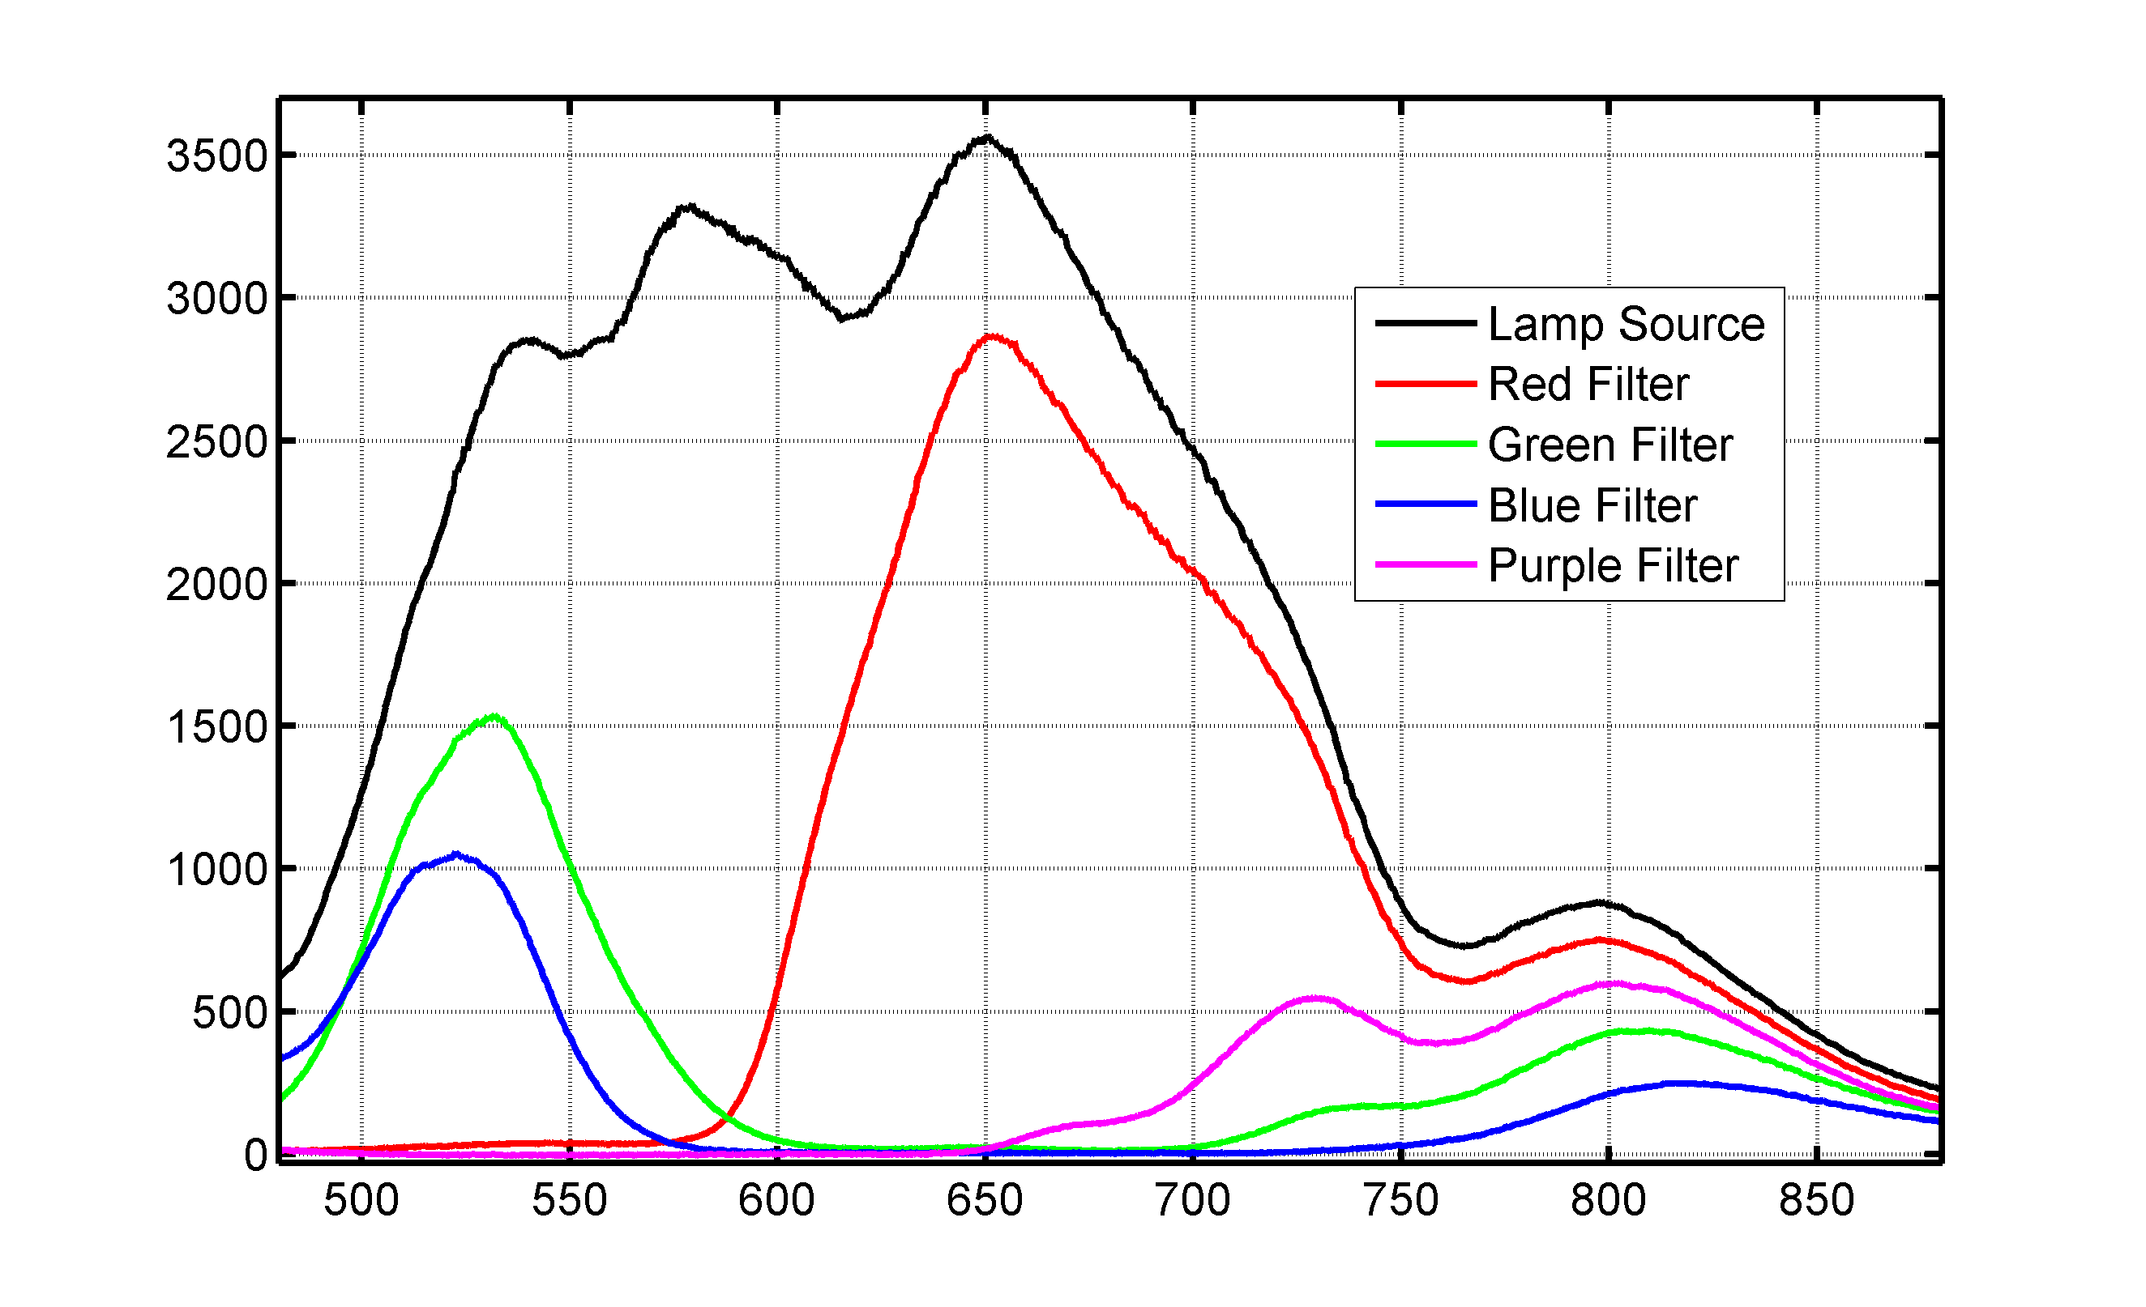
Figure 23 - Spectrograph transmission readings of four color dye filters

All the spectrum readings of Figure #23 were taken in the same session with the same integration times. In other words, the data is scaled correctly so we can compare both amplitude and frequency.

The rest of the spectrum readings in the third experiment are reflection readings with the light source at -45 degrees and the spectrum probe 6 millimeters away from the ferrofluid layer at zero degrees normal. Both the camera and fiber optic probe have the same orientation, and all the spectrum readings share the same integration times and are scaled correctly. All the photographs, and color channels of the photographs, share the same f5 f-stop and 1/13 of second exposure times with minimal processing.

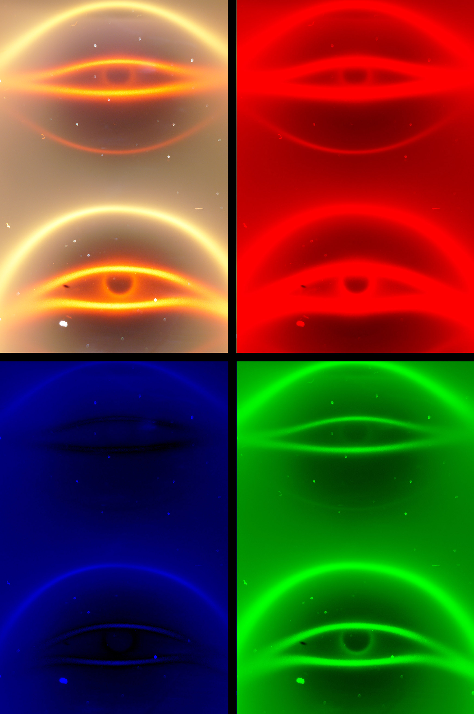
Figure 24 - Baseline over-exposed picture of two magnets with no color filter.

Figure #24 is a baseline photograph without a filter. Because the filters will attenuate the incandescent light source, the photograph is a bit over-exposed. The red, green, and blue channels of the photograph are shown adjacent to the original image and have not been rescaled. For example, the red layer of Figure #24 is saturated with red light.

Using two magnets of the nine magnets seen in Figure #12, in a plastic jig as a test subject, which is providing the applied magnetic filed. One magnet has the north pole and the other magnet has a south pole aligned with the ferrofluid cell. In Figure #24, the light is coming from the direction of the bottom of the photograph and the hysteresis pattern on the lower 1/2 of the page is closer to the light source than the hysteresis pattern on the upper 1/2 of the page.

Note in Figure #24 that we have a glass flaw on the glass surface which is casting a shadow. I find that these shadows are good at providing standardized readings, defining the light level at the center of the shadow as the baseline.

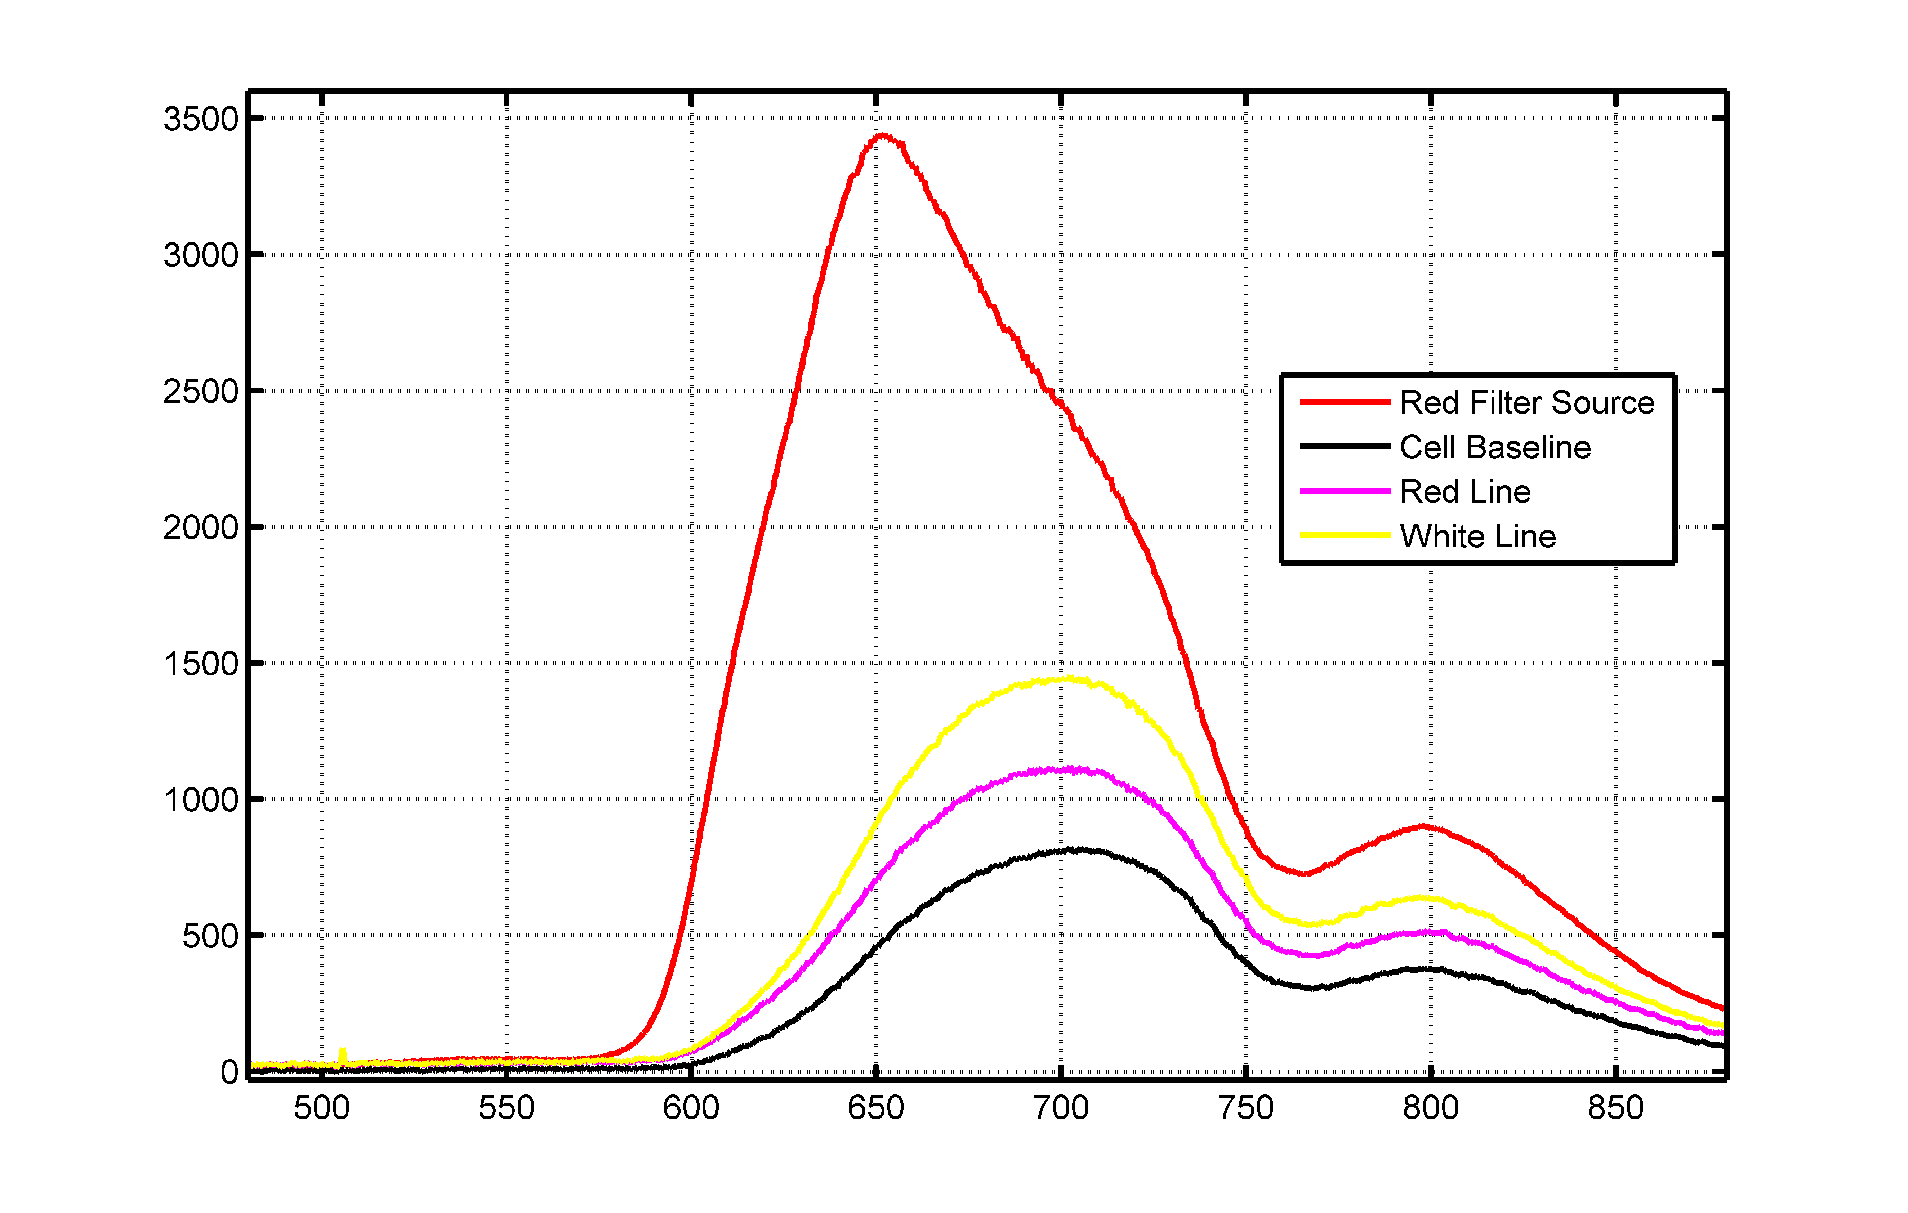
Figure 25 - Spectrograph readings of the red filter with the ferrofluid cell.

In Figure #25, I am showing the spectrum results of the 'red' filter. The black line is the reflection profile of the ferrofluid cell without an applied magnetic field. The magenta line of the graph shows the reflection profile of having a red hysteresis line under the fiber optic probe and the cyan line shows the reflection profile of having a white line, or the eye brow feature. These alignments of the fiber optic probe with the image features are best effort and probable need to be repeated in a few more experiments.

One of the interesting parts of the Figure #25, is that the spectrum background response of the red hysteresis line, and the white eye brow line, all share the same spectrum profile with mainly just differences of amplitude and some small changes below 600nm.

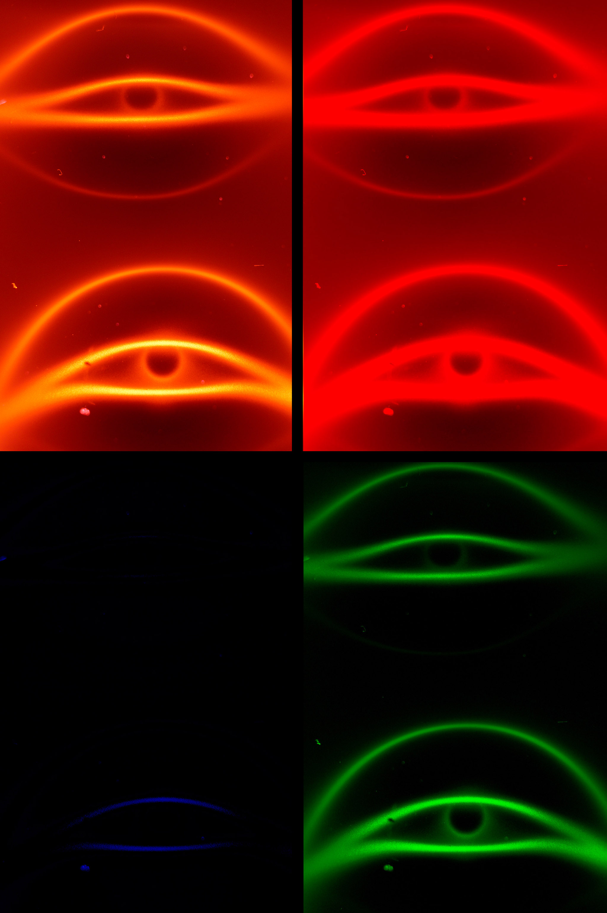
Figure 26 - Picture of north and south magnetic poles using a red filter.

This leads to the thought that all the lines that show up in the ferrofluid images come from the same mechanism. What ever the mechanism happens to be, Figure #25 suggests that we are just looking at it at different angles and different intensities.

In Figure #26, I am showing the effects of the 'red' filter on the test subject. Not surprisingly the ferrofluid cell is scattering mostly red light to the camera.
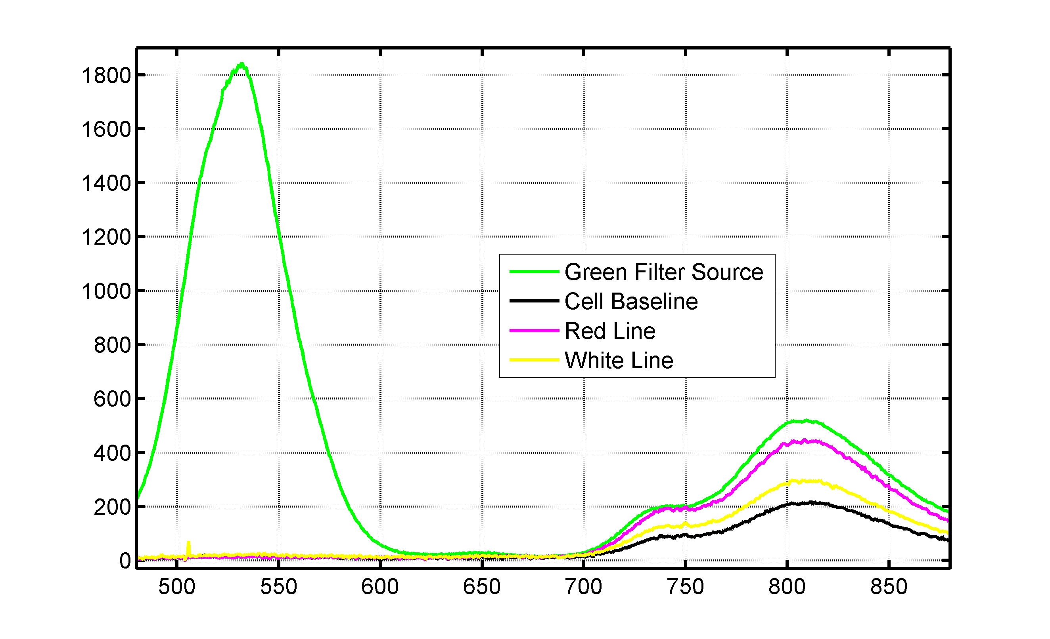
Figure 27 - Spectrograph readings of the green filter with the ferrofluid cell.

Figure #27 is showing the effects of the 'green' color filter. Ironically, there is not much information in the green frequencies but plenty in the infrared. When I apply a magnetic field, the amplitude of the infrared spectrum profile changes. Note the persistence of the hysteresis shape in Figure #28. It scatters red light as in Figure #26 and it scatters green light in Figure #28. To say that the hysteresis shape is a multi-wavelength feature is an understatement.

One does not apply a magnetic field and accidentally get an hysteresis shaped pattern. Another thing to note in Figure #28 is the low gauss edge effect. The two magnets probably have a reading of around 500 gauss at the ferrofluid layer which will quickly drop off around the edges of the image. At the edges of the image we have a large amount of green scatter yet at the center we have very little.

Figure #28 is showing red light in the red color channel of the photograph. Not sure how this happened. It could be that the dye filter allowed enough red photons into system to be picked up by the camera or the camera might be picking some NIR in the red channel. A better equation is why does Figure #30 not show the same features? The green and blue dye filters share a lot of common frequencies and all the photos in this section have the same exposure times.

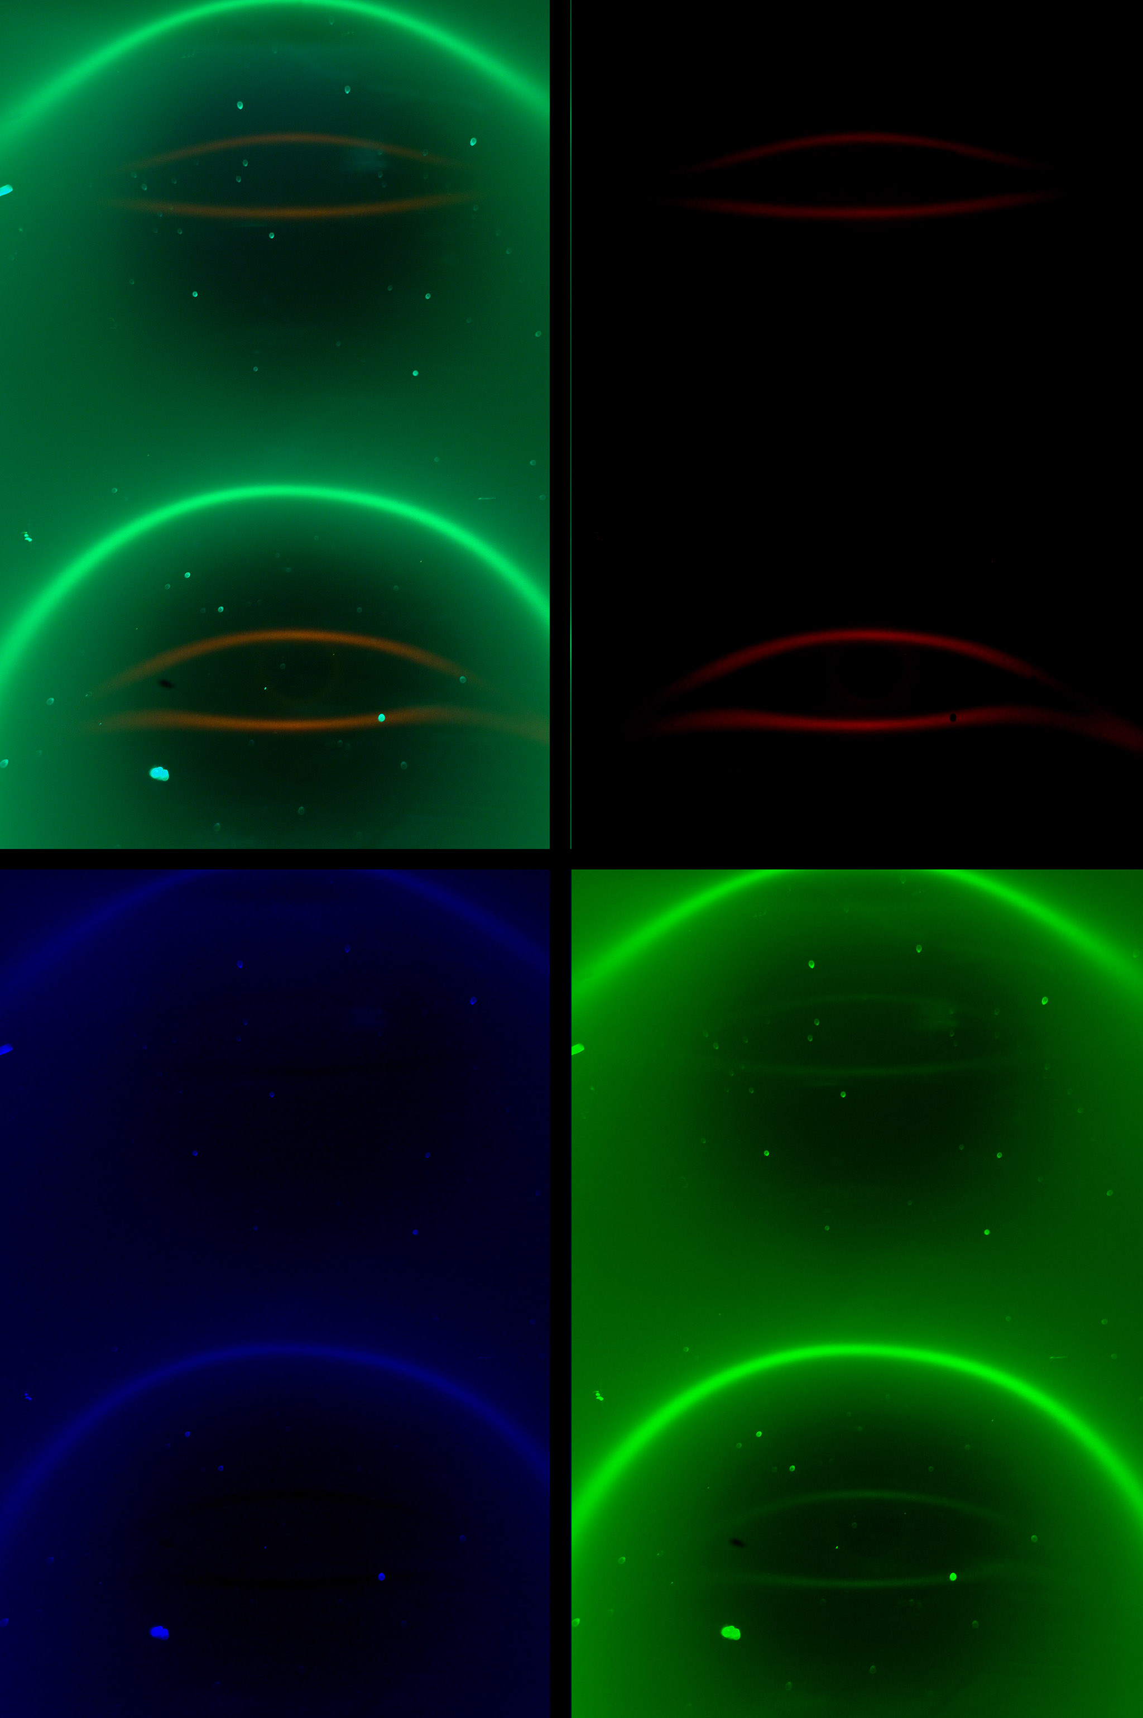
Figure 28 - Picture of north and south magnetic poles using a green filter.

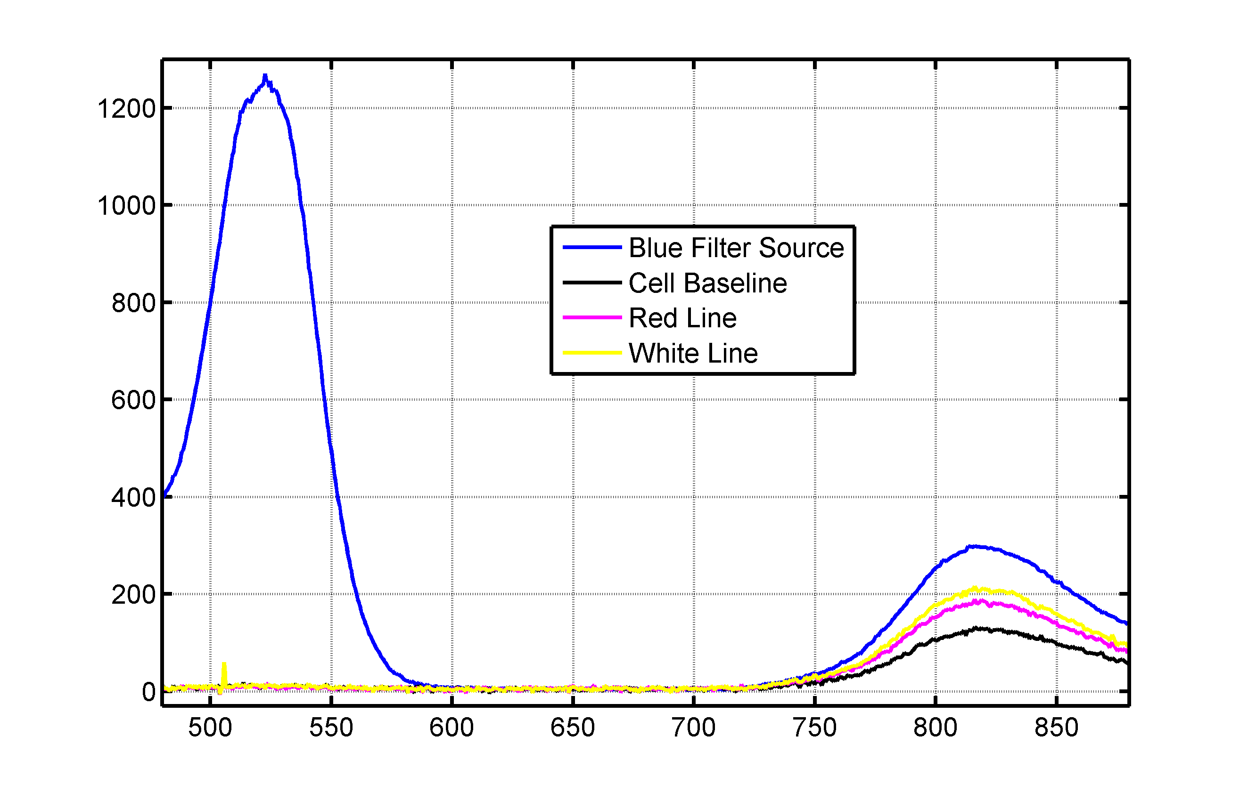
Figure 29 - Spectrograph readings of the blue filter with the ferrofluid cell.

In Figure #29, I am showing the ferrofluid cell responses to the 'blue' filter. More correctly, the non-scattering of the blue light. If it wasn't for the infrared readings I would thought that we had an equipment problem.

In Figure #29, we are showing the effects of the 'blue' filter from the viewpoint of the camera. Interesting we still have the low gauss edge effect and the white eye brow line but the hysteresis shape is missing in the blue channel.

Not sure what to make of this because the baseline blue channel of Figure #24 has the hysteresis shape but it is missing in the blue channel of Figure #30. More experiments will be needed to explain this inconstancy. Is the blue pattern from the baseline image missing, or did we not met a minimum level of blue photons to show it?

The light levels from the white dust and the flaws in the glass seem to show that the camera is working properly in Figure #30..

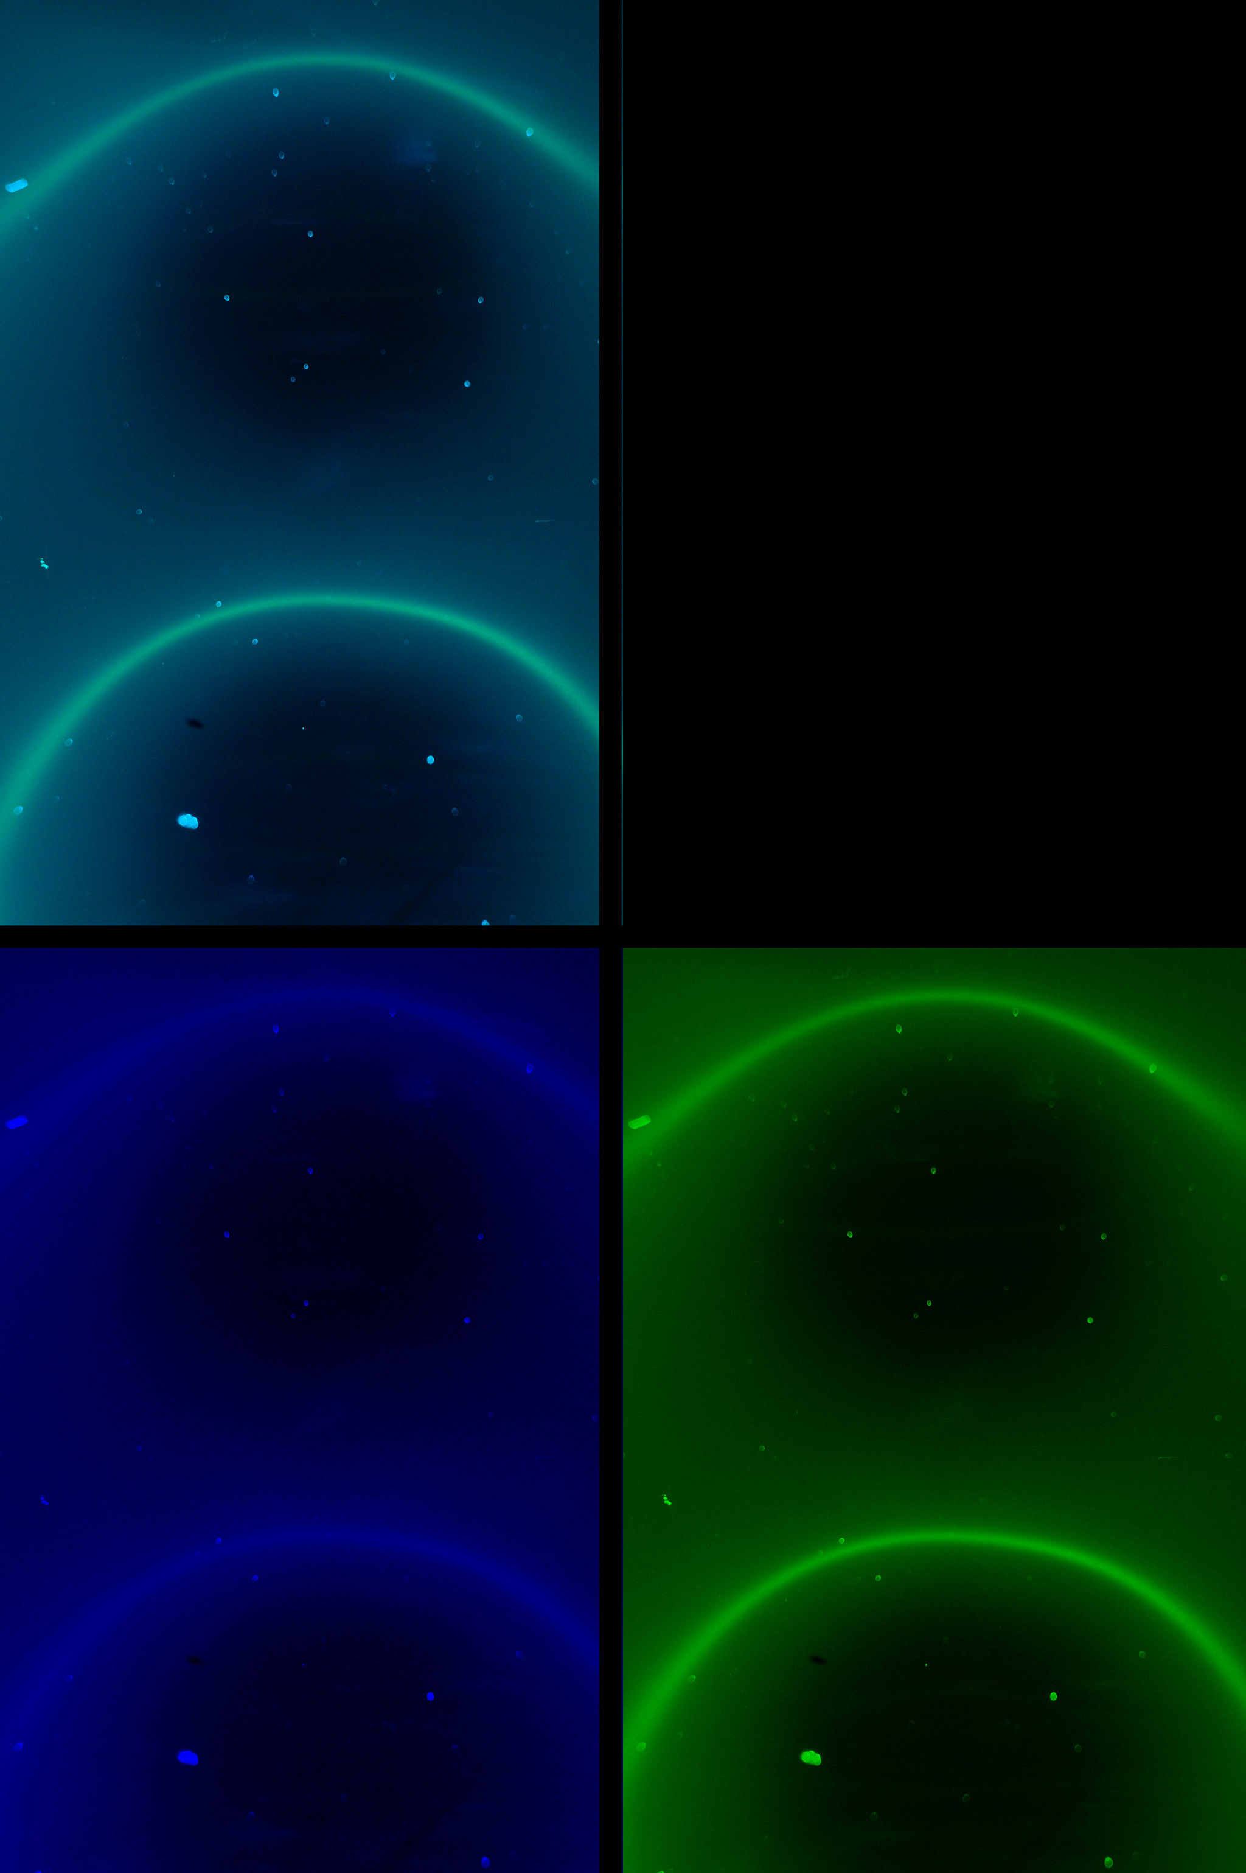
Figure 30 - Picture of north and south magnetic poles using a blue filter.

Fourth Experiment: After my spectrometer showed that the ferrofluid cells scatter light at infrared frequencies; I wondered about the infrared images, and proceeded to convert one of my Nikon 995 cameras to be sensitive IR frequencies.

I removed the ‘Hot Mirror’ in front of the camera's CCD and this allows the camera to see in the 700-1000nm range. Then I used a set of IR camera filters to block the visible frequencies. The filter set came with 720nm, 850nm, and 950nm filters.

The 720nm camera filter passes some visible red frequencies and they are showing up in the red data channel of the camera. The modified blue and green channels pick up about the same amount of the IR signal which then shows up as the color white in Figure #32 and Figure #33. Figure #31 is a picture of the applied field of the nine magnets from Figure #12.

The pixel noise in Figure #33 comes from the eight second exposure times needed at 950nm. Basically Figure #31, Figure #32, and Figure #33 are confirming the NIR spectrograph readings of Figure #16. In other words, the ferrofluid cells work in NIR frequencies and we can find the same structures in the NIR photographs as the optical frequencies. Notice the 'red', 'yellow' and 'brown' features are present in NIR.

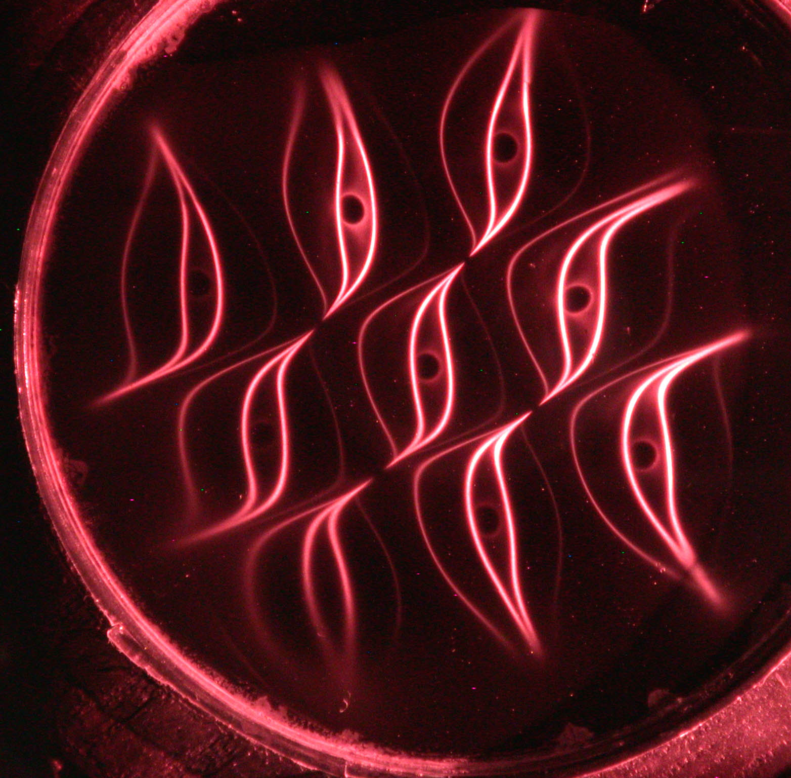
Figure 31 – Ferrofluid cell with nine magnets using a 720nm camera filter.
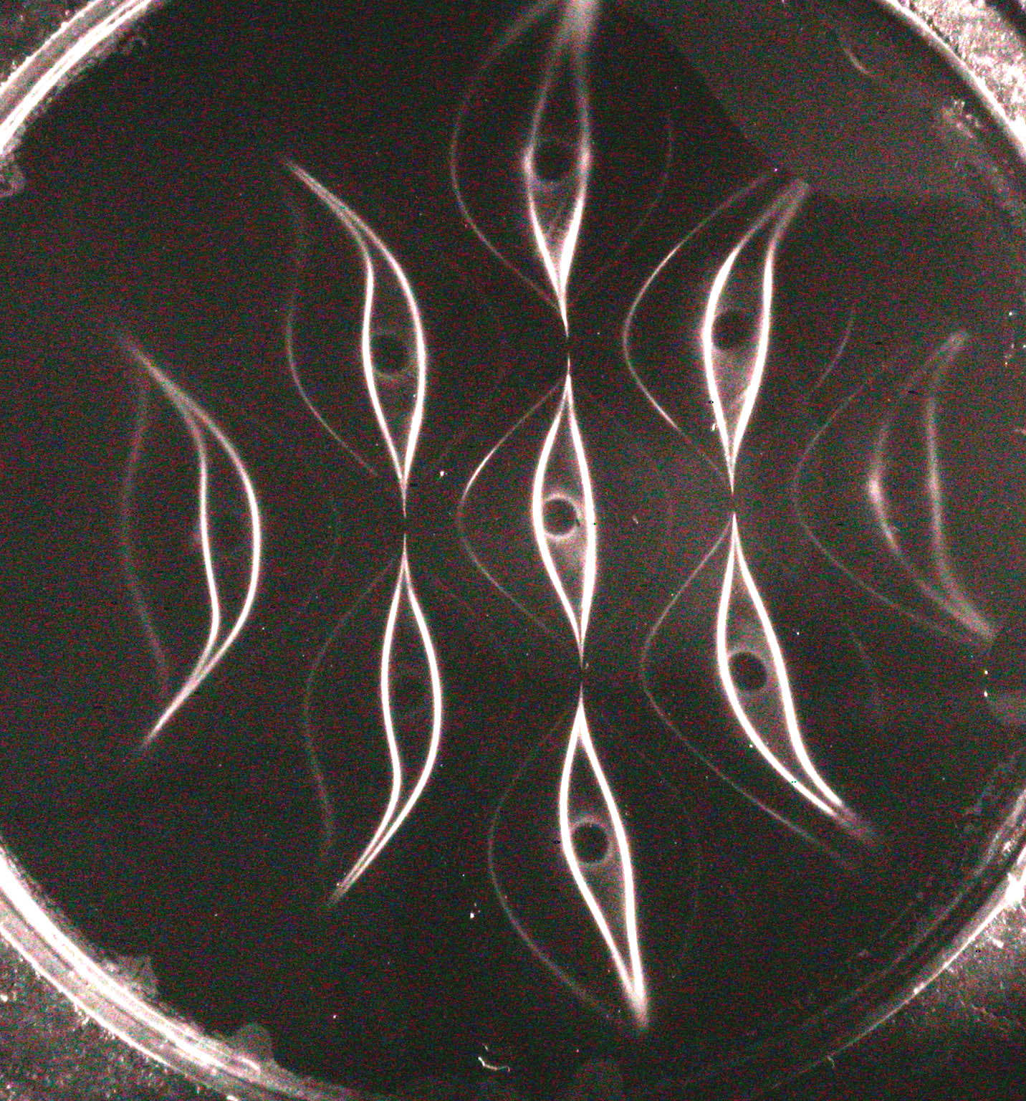
Figure 32 – Ferrofluid cell with nine magnets using a 850nm camera filter.
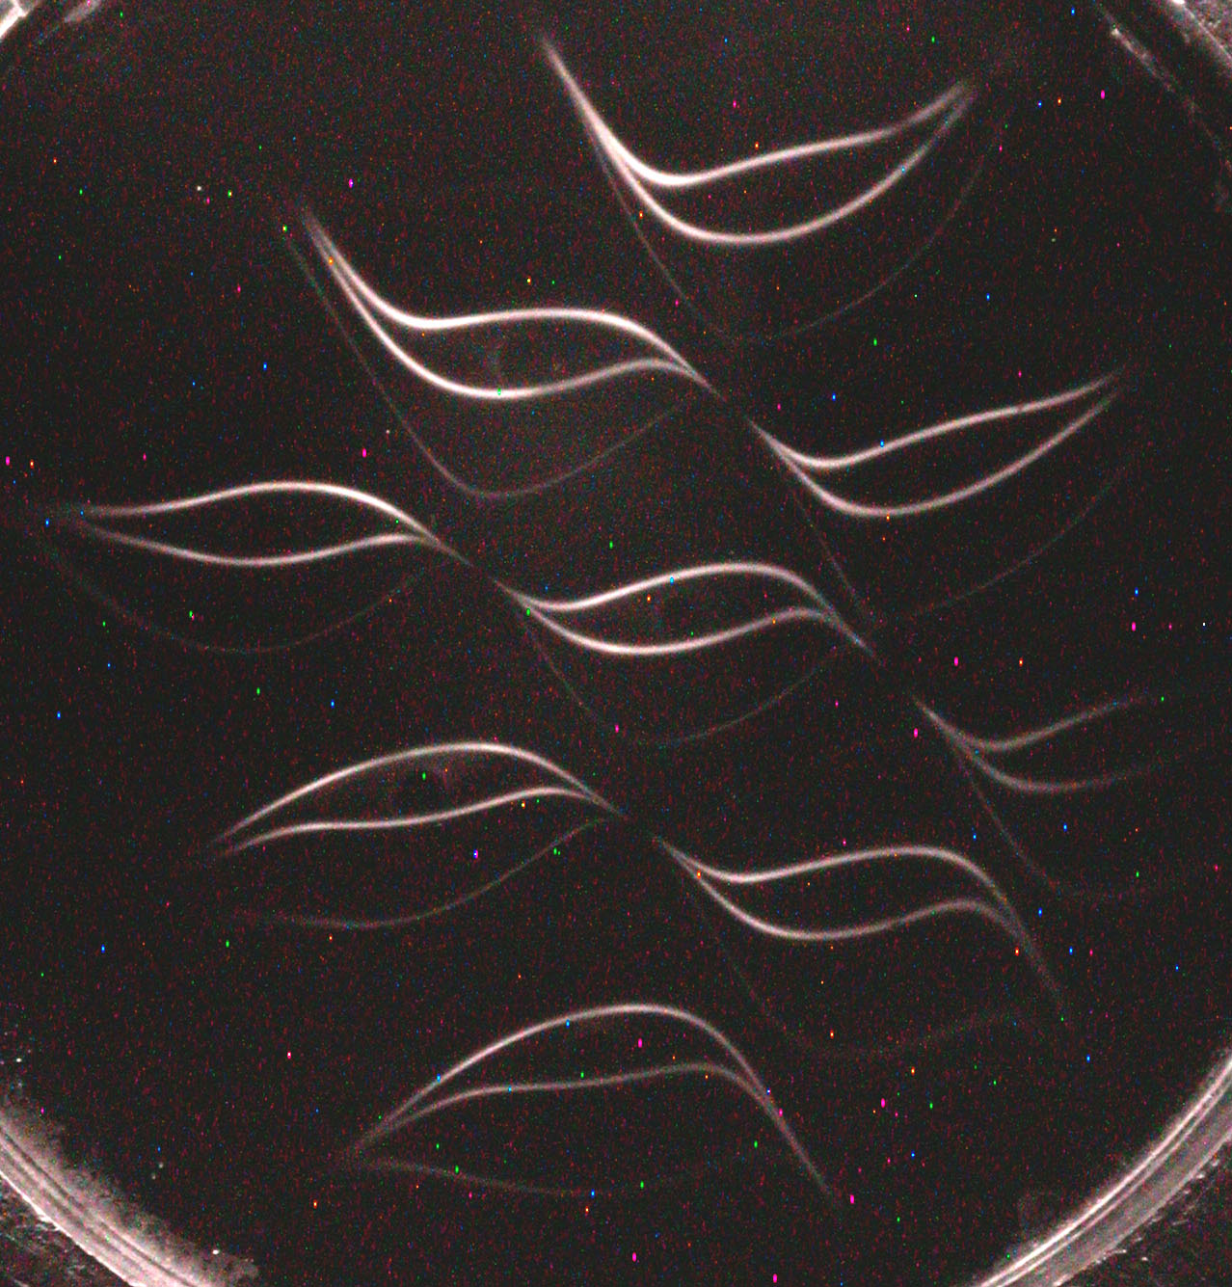
Figure 33 – Ferrofluid cell with nine magnets using a 950nm camera filter.
Fifth Experiment: This is the last experimental section of the paper. I collected photon scatter based on angle and polarization data of a ferrofluid cell without an applied magnetic field but in a cell that had been recently used the same week.

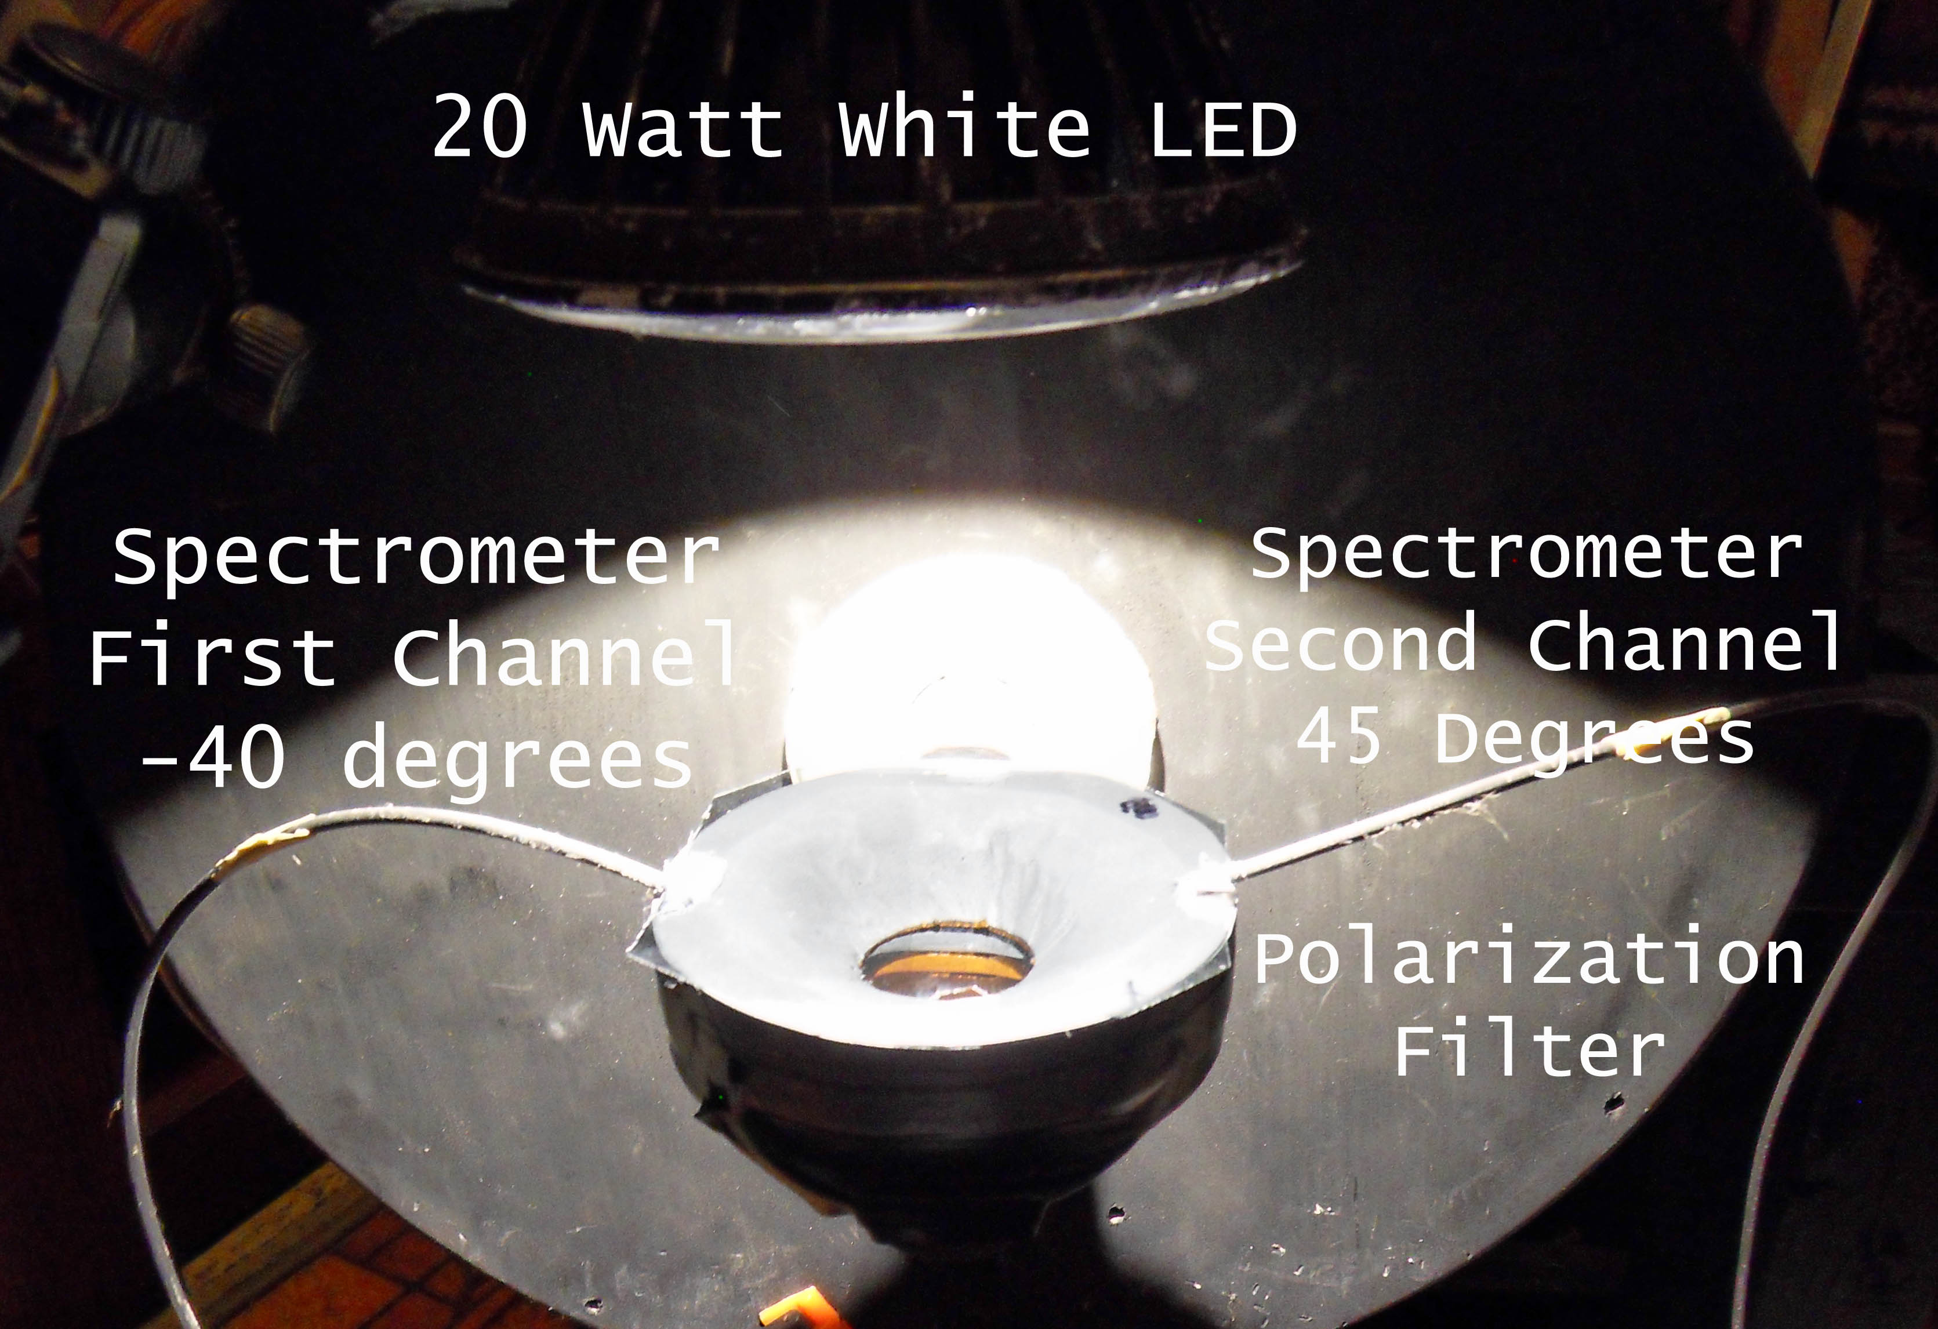
Figure 34 – Layout of the experiment, the light source can be rotated around the cell.

In Figure #34 I am showing the layout of my experiment. The fiber optic probes are embedded in a PVC plastic mount in holes pointed at the ferrofluid cell.

The idea behind the apparatus is that the light can only enter the fiber optical probes from a known angle. Because we know the angle of the probe in relation to the ferrofluid cell's mirror and the probe is shaded from direct light, then only light from known angles can be picked up by the spectrometer. Another benefit is that each channel can confirm the other channel's readings but at different times during the lab run because the two angles are complementary with a common light source.

The light source can be rotated around the ferrofluid cell at constant distance to the center of the cell. The light source is a consumer grade 20 watt white light LED with a flat emitting surface of about a square centimeter. This produces a cone of light of constant brightness which is good enough for doing a preliminary experiment. Ideally the fiber optic probes should be pointed at the dead center of the ferrofluid cell but my readings will only be taken at every five degrees which should mitigate any induced parallax error.

On top of the ferrofluid cell in Figure #34, you will see a polarization filter that looks like a square piece of plastic film. Notice that there’s a black dot on the right rear corner. The polarization filter is a commercial grade filter sold in sheets. The polarization direction of the plastic sheets is not marked therefore I will call the direction of the filter shown in the figure as Polarization One and if we rotate the black dot 90 degrees to another corner of the ferrofluid cell, that is defined as Polarization Two.

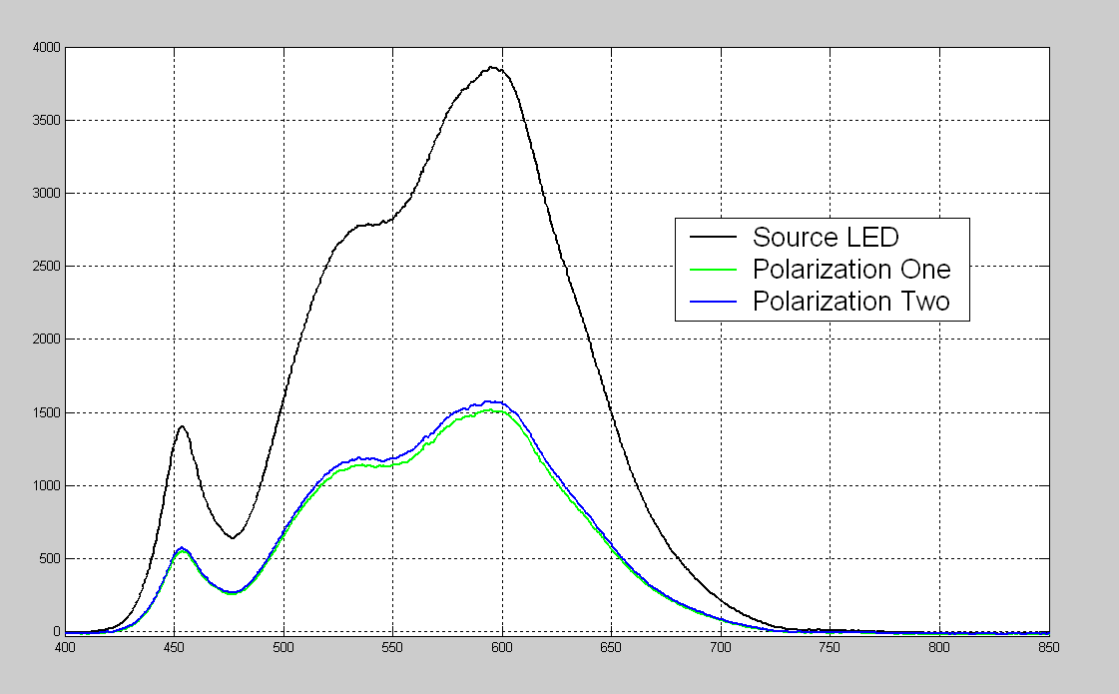
Figure 35 – Spectra readings of the light source, notice the 454nm signal.

In Figure #35 I am showing the spectrometer readings of the light source, notice that spectrum is a bit uneven for a product sold as a white light and has pronounced shoulders around a 454nm peak. The blue and green lines of the figure show the light source readings after passing through the polarization filter.

Figure #36 is showing the readings for different incidence angles of the light source. One may wonder how I got readings at exactly 90 degrees? The answer is that I took a bunch of readings and the one with the highest amplitude was defined as being at 90 degrees of incidence. We can do this if we assume the aluminum surface mirror will produce a larger signal versus the scatter contributions of the ferrofluid layer.

Speaking of signal, where the heck did the 454nm signal go in Figure #36? We know the light source is producing a lot of 454nm photons but ferrofluid cell isn’t scattering them back to the fiber optic probe. When I saw this reading, I stopped the experiment and started checking all my connections and took different readings of the polarization filters and the light source , and verified everything I could verify. The readings were the same with both spectrometer channels.

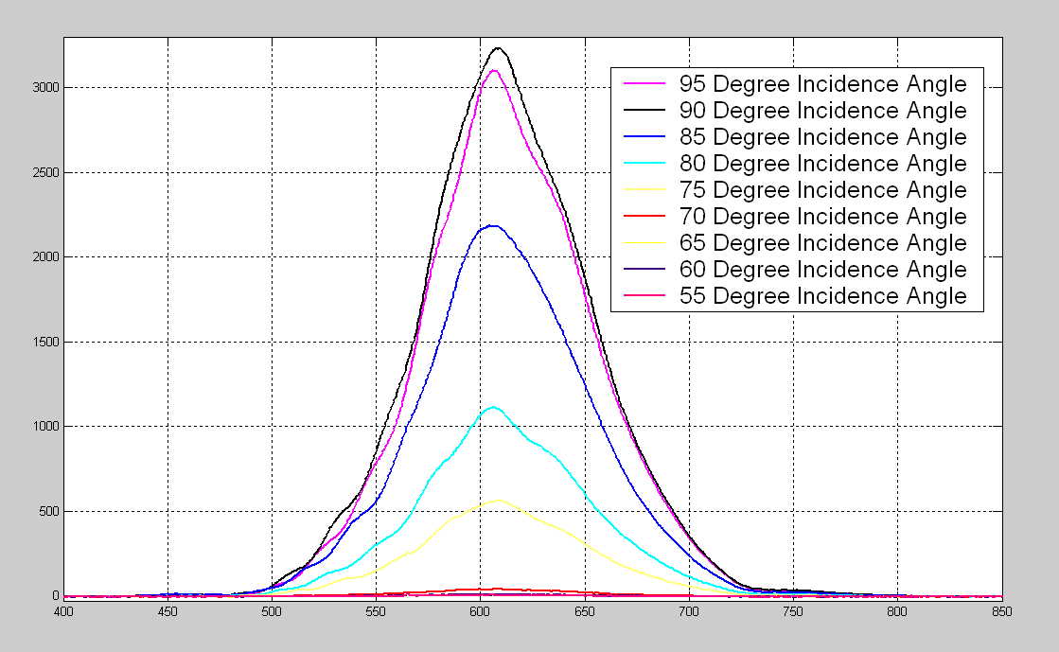
Figure 36 – Scatter readings at different angles for Polarization One.

During the process of looking for the reason for the missing 454nm photons, I tried the Polarization Two position and found my photons! Figure #37 shows that the Polarization Two filter allows 454nm photons to be scattered into the spectrometer.

I am only showing eighteen readings in this section but the second spectrograph channel showed the same effect; one polarization position produced a 454nm signal and the other polarization position did not produce the same signal, as shown in Figure 40.

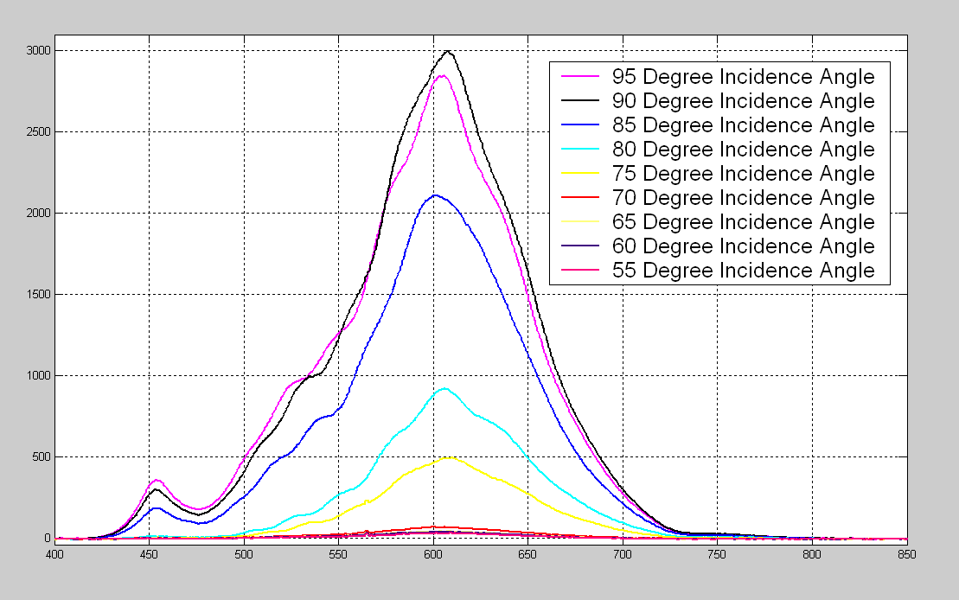
Figure 37 – Scatter readings at different angles for Polarization Two.
When I am taking these readings, literally nothing moves other than moving the polarization filter. In Figure #38 I am showing the readings for 90 degree incident angle spectra with and without the polarization filter. Clearly with no filter and with Polarization Filter Two we have the 454nm signal but not with Polarization Filter One.

I notice that the blue line in the Figure #38 resembles the spectrum of the ferrofluid cell with an applied magnetic field producing yellow lines from previous sections, and the green line resembles the spectra of ferrofluid cell with an applied field producing the red lines.

In other words, the polarization of the light inside the ferrofluid cell is linked to the different color features that we see in the ferrofluid photographs.

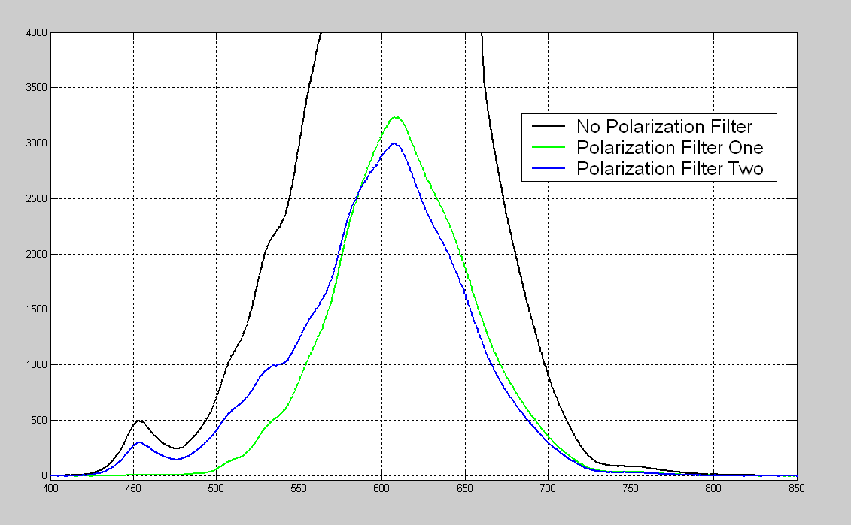
Figure 38 – Ferrofluid cell spectrum readings at a 90 degree incident angle.

In Figure #39 light in divided by light out gives us the spectrum scattering response of the ferrofluid plus the mirror, at a 90 degree incident angle. Basically Figure #39 is stating that the ferrofluid cell is optically active at around 445nm, and the polarization of the light is affecting the activity rates.
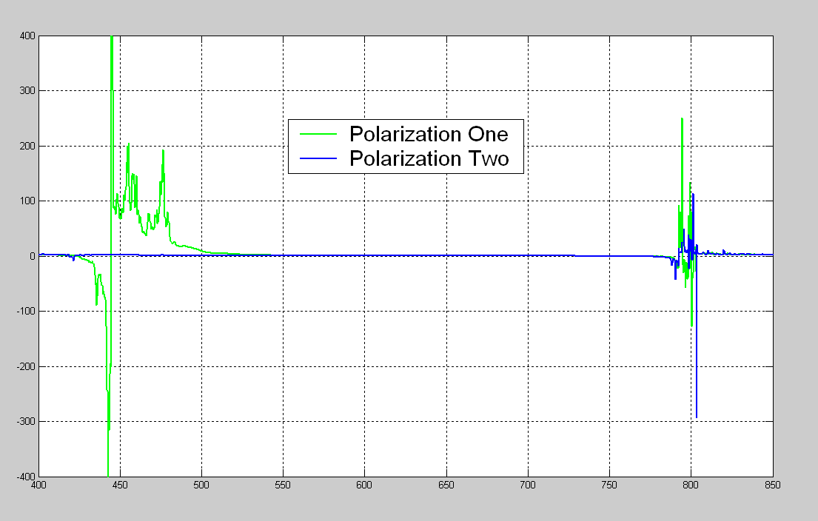
Figure 39 – Scattering response of the ferrofluid cell at a 90 degree incident angle

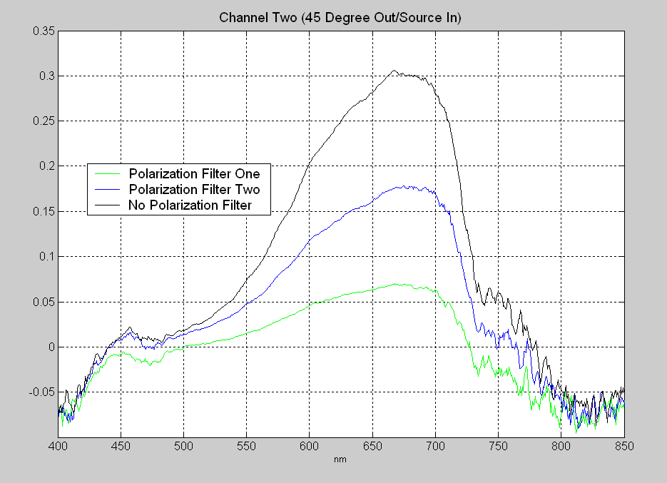
Figure 40 – Scattering response of the ferrofluid cell at a 45 degree incident angle

In Figure #40, we are confirming the spectrum reading differences between horizontal and vertical polarization in the second data channel at a 45 degree angle of incidence.
The reason for the slightly negative numbers is do the baseline subtraction procedure for processing spectrums, and is considered normal for this type of graph. The 20 watt white light source, seen in Figure #35, is not producing much signal strength at frequencies greater than 700nm which leads to the choppy appearance above 700nm.

In an effort to see all the spectrum, I repeated the experiment using an incandescent heat lamp and the PC1000 NIR spectrometer which is shown in Figure #41. Clearly there is an difference between horizontal and vertical polarizations in the ferrofluid cell and I have confirmed the readings on three different spectrometers.

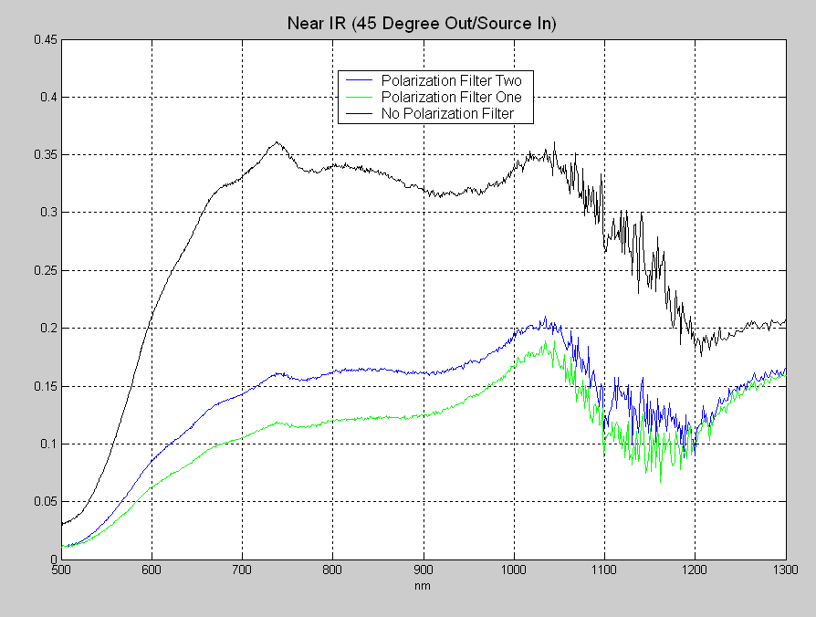
Figure 41 – NIR Scattering response of a cell at a 45 degree incident angle

To put these findings in context, imagine looking at an ocean while using a pair of sunglasses and seeing a green ocean, and then tilting your head and seeing a blue ocean.

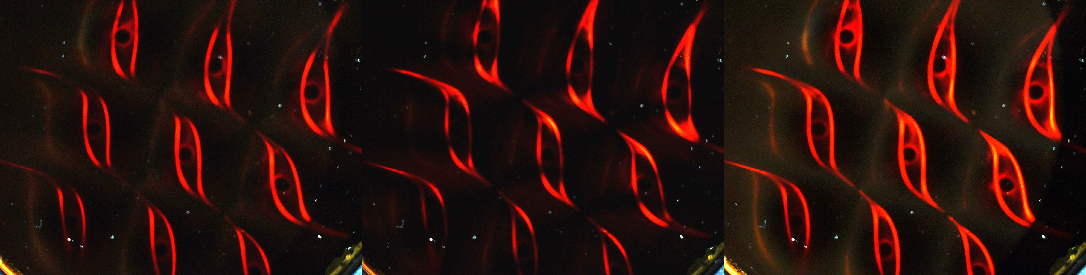
Figure 42 - Using a polarizing filter on the camera while viewing a ferrofluid cell.
Earlier I mentioned that the color of the yellow lines and the polarization of the yellow lines seen in the ferrofluid cell pictures where linked together. In Figure 42, I show three pictures that was taken in consecutive order with the only change of a linear polarizer being rotated on the camera. Notice the middle picture where the yellow lines, the eyebrow shapes, are well attenuated. Not one or two of them, but all nine yellow lines at once can be effected by the camera's polarization filter.

I believe this is ample proof that all the lines are produced using the same mechanism but with minor spectrum changes based on polarization.

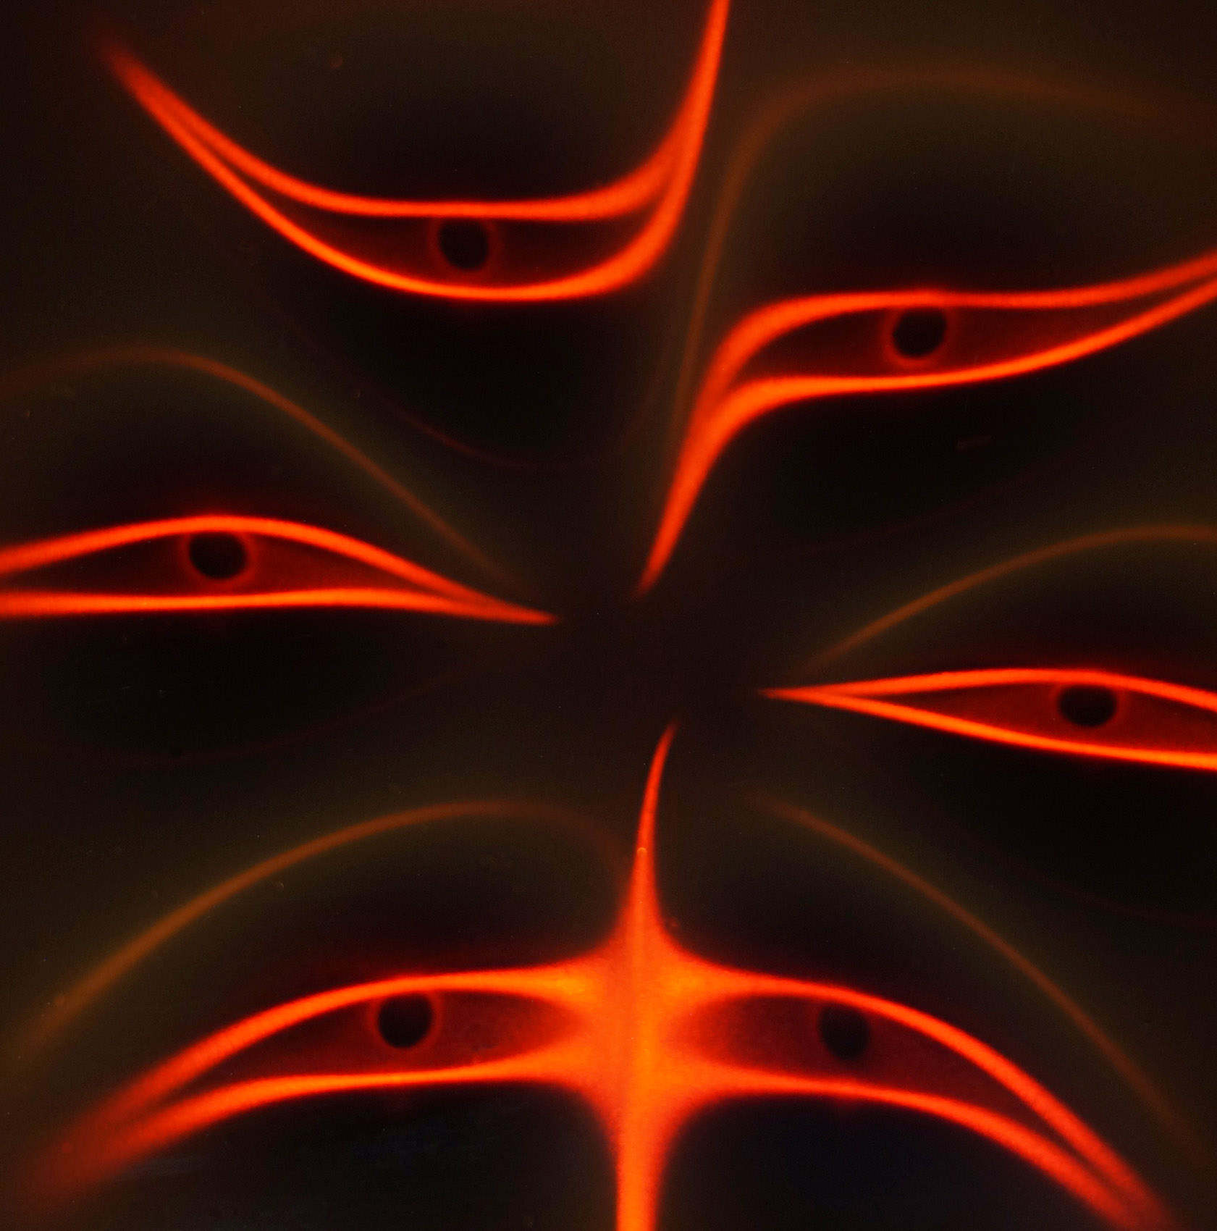
Figure 43 - Ferrofluid cell with magnets in a circle.

Summary: I have extraordinary evidence that the ferrofluid cells do not obey the rules of classical optics. The main problem being the question of how do you characterize such a system? Can you call it a Kerr photonic crystal, or can you call it a metamirror? Just calling it magnetically controlled chiral dichroic reflection seems a bit unsatisfactory.

My work is different from the mainstream 'Magnetic Fluid Deformable Mirrors' or the 'Metal Liquid Like Films' because I am only using the optics of ferrofluid itself with large magnetic fields that are producing self-assembled magnetic agglomerate clusters.
The proof is in the pudding; if Figure #44 is not created with resonating magnetic agglomerate clusters, then how is it created? I see resonant displacement currents propagating inside the ferrofluid cell and it is the current(s) that are scattering the light.

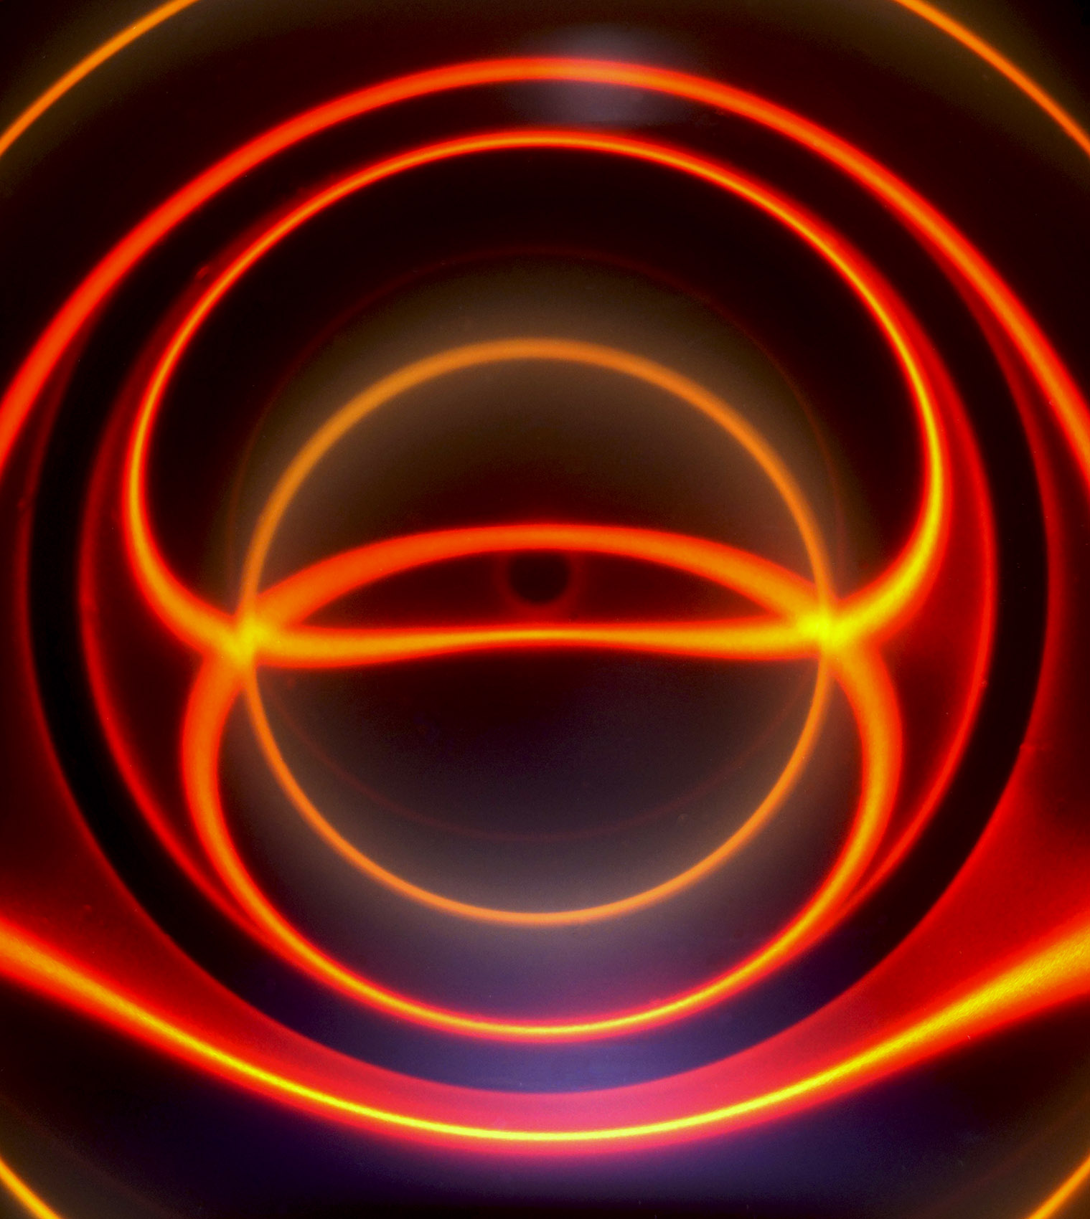
Figure 44 – Ferrofluid cell readings with a 50mm ring magnet behind the cell.

References & Resources:

1) Yang, S.y., H.e. Horng, Y.t. Shiao, Chin-Yih Hong, and H.c. Yang. "Photonic-crystal Resonant Effect Using Self-assembly Ordered Structures in Magnetic Fluid Films under External Magnetic Fields." Journal of Magnetism and Magnetic Materials: 43-47.
2) Qian, Zhaoxia, Simon P. Hastings, Chen Li, Brian Edward, Christine K Mcginn, Nader Engheta, Zahra Fakhraai, and So-Jung Park. "Raspberry-like Metamolecules Exhibiting Strong Magnetic Resonances." ACS Nano (2015): 1263.
3)V. S. Asadchy, Y. Ra’di, J. Vehmas, and S. A. Tretyakov. " Functional Metamirrors Using Bianisotropic Elements" Phys. Rev. Lett. 114, 095503 – Published 6 March 2015
4) Snyder, M. and Frederick, J. (2009), 'Photonic Dipole Contours of Ferrofluid Hele-Shaw Cell', Reinvention: a Journal of Undergraduate Research, Volume 2, Issue 1 http://www2.warwick.ac.uk/go/reinventionjournal/issues/volume2issue1/snyder
5) 2008 APS March Meeting Abstract: H32.00012 : 'Ferrofluid Photonic Dipole Contours http://meetings.aps.org/Meeting/MAR08/Session/H32.12
6) APS Website and 2012 APS Calendar http://www.aps.org/about/physics-images/archive/heleshaw.cfm
7) NSF Visualization Challenge Finalist 2009 & 2013 https://nsf-scivis.skild.com/skild2/nsf2013/viewEntryDetail.action?pid=48989
8)Timm Vanderelli of Ligonier, Pennsylvania. USPTO patent application #20070241745
Magnetic Flux Viewer. <http://nanomagnetics.us>
9) "Michael Monroe Snyder." Facebook. Web. 30 Mar. 2015. <http://www.facebook.com/ferrofluidcells>

